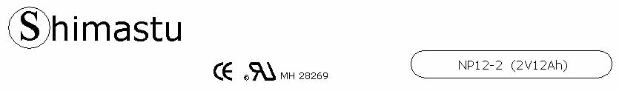

PHYSICAL SPECIFICATION
Nominal Voltage  Nominal Capacity (20HR) |  |  |  | 2V  12Ah |  | 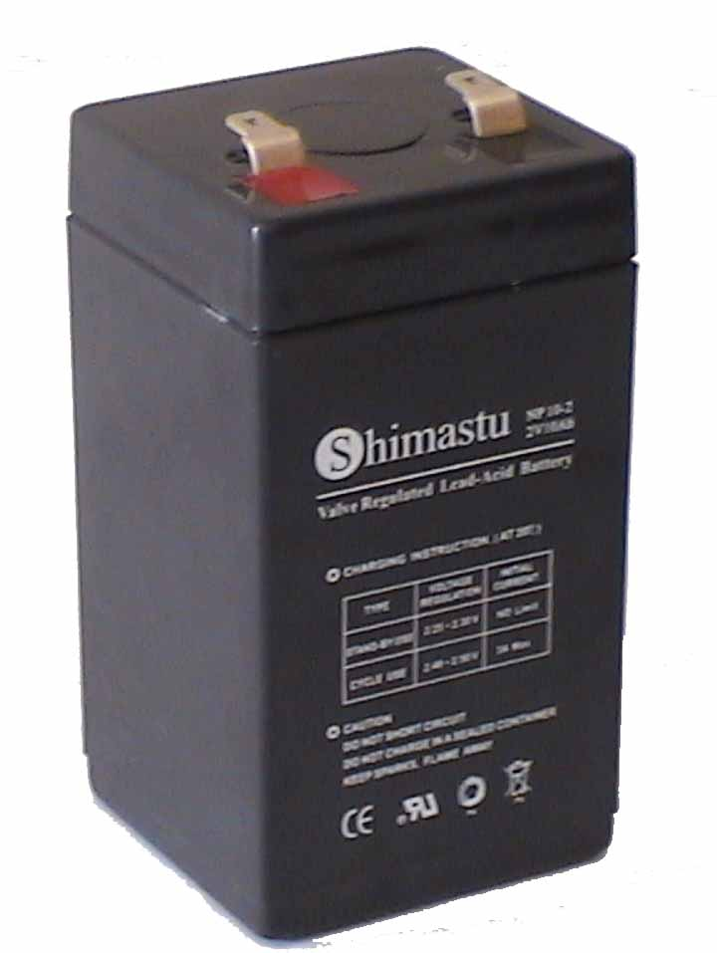
Dimension |  | Length  Width  Container Height  Total Height |  | 52±1mm (2.05 inches)  52±1mm (2.05 inches)  93±1mm (3.66 inches)  98±1mm (3.86 inches)
Weight |  |  |  | Approx. 0.7 Kg ( 1.54lbs)
Standard Terminal |  |  |  | Fasten Tab No.187E
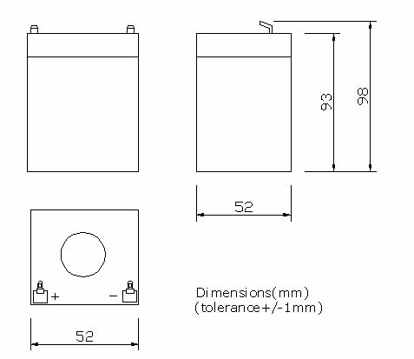 |  |  |  |  |  | 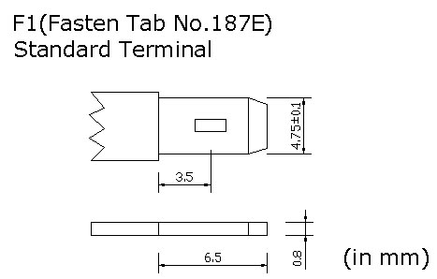

ELECTRICAL SPECIFICATION
Characteristics |  |  |  |  |  | Discharge curves @ 25℃ (77 °F)
Capacity |  |  | 20 hour rate (0.6A)  10 hour rate (1.08A)  5 hour rate (2.04A)  3 hour rate (3A)  1hour rate (7.2A) |  | 12Ah  11.4Ah  10.2Ah  9Ah  7.2Ah | 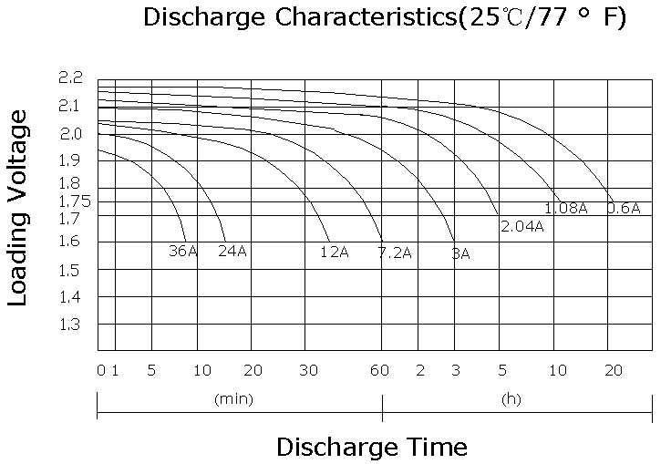
Capacity affected  by temperature |  |  | 40℃ （104 ⁰F）  25℃ （77 ⁰F）  0℃ （32 ⁰F） |  | 102%  100%  85%
Internal Resistance |  |  | Full charged battery (25℃,77 ⁰F) 10mΩ
Constant Voltage  Charge | Cycle |  | Initial Charging Current less than 3.6A  Voltage 2.4~2.5V at 25℃ (77 ⁰F )  Temperature Coefficient –18mV/℃
Constant Voltage  Charge | Standby |  | No limit on Initial Charging Current  Voltage 2.25~2.3V at 25℃ (77 ⁰F )  Temperature Coefficient –18mV/℃

