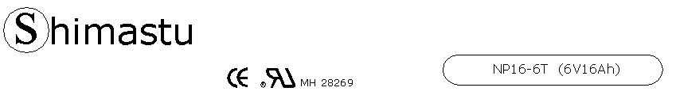

PHYSICAL SPECIFICATION
Nominal Voltage  Nominal Capacity (20HR) |  |  |  | 6V  16Ah |  | 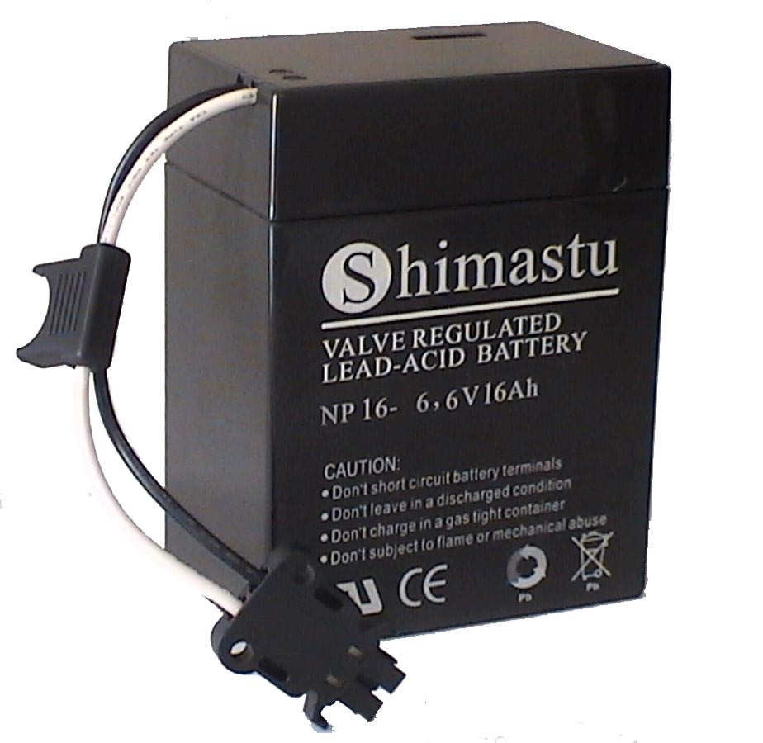
Dimension |  | Length  Width  Container Height  Total Height |  | 108±1mm （4.25 inches）  71±1mm (2.80 inches)  139±1mm (5.47 inches)  139±1mm (5.47 inches)
Weight |  |  |  | Approx. 2.54Kg ( 5.60lbs)
Standard Terminal |  |  |  | Connector
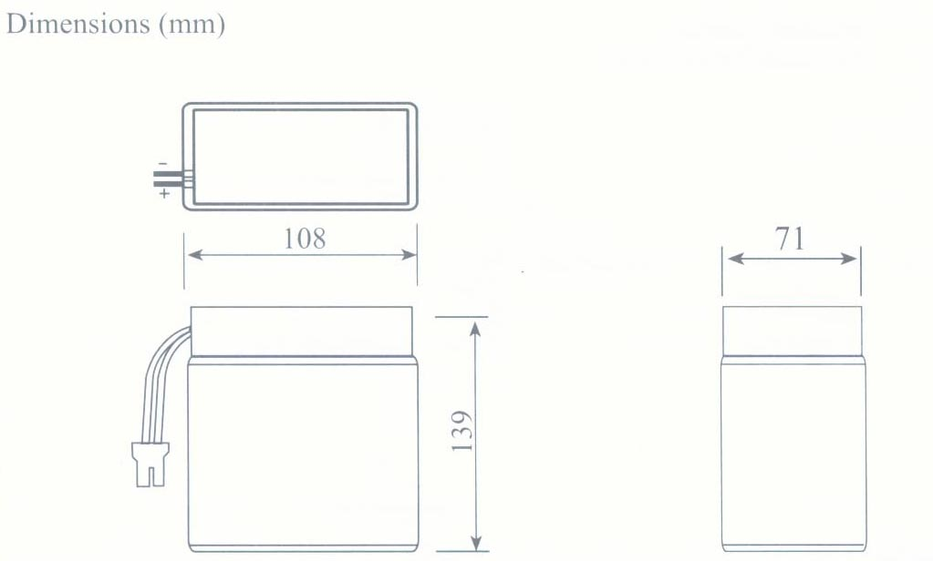 |  |  |  |  |  | 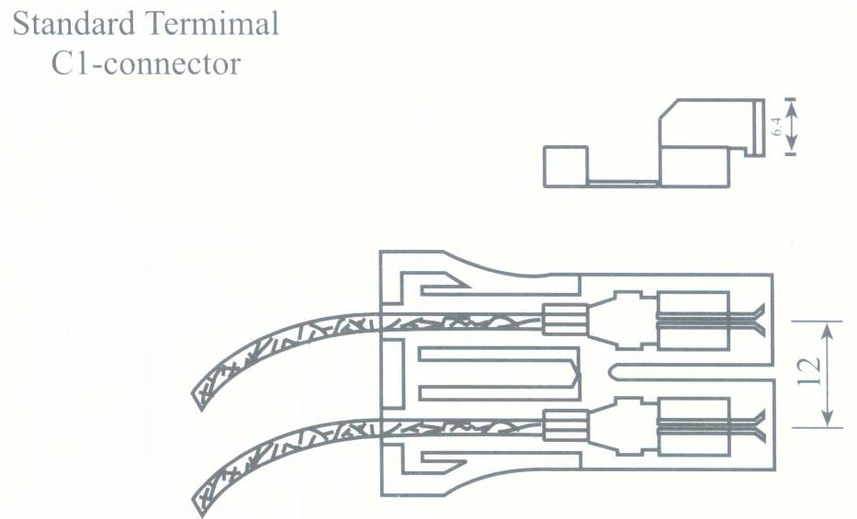

ELECTRICAL SPECIFICATION
Characteristics |  |  |  |  |  | Discharge curves @ 25℃ (77 °F)
Capacity |  |  | 20 hour rate (0.8A)  10 hour rate (1.44A)  5 hour rate (2.72A)  3 hour rate (4A)  1hour rate (9.6A) |  | 16Ah  15.2Ah  13.6Ah  12Ah  9.6Ah | 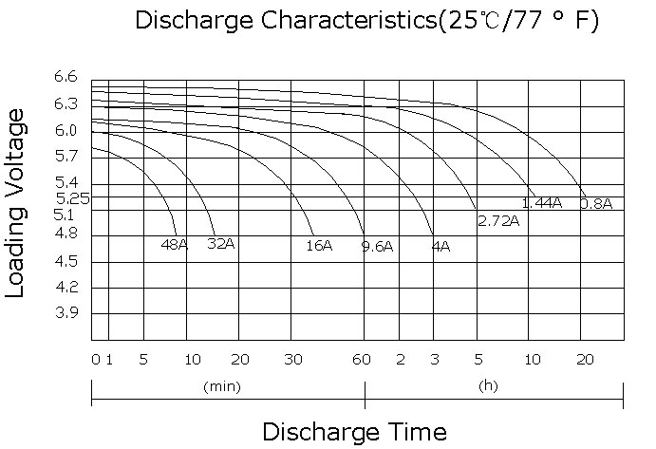
Capacity affected  by temperature |  |  | 40℃ （104 ⁰F）  25℃ （77 ⁰F）  0℃ （32 ⁰F） |  | 102%  100%  85%
Internal Resistance |  |  | Full charged battery (25℃,77 ⁰F) 10mΩ
Constant Voltage  Charge | Cycle |  | Initial Charging Current less than 4.8A  Voltage 7.20~7.50V at 25℃ (77 ⁰F )  Temperature Coefficient –15mV/℃
Constant Voltage  Charge | Standby |  | No limit on Initial Charging Current  Voltage 6.75~6.90V at 25℃ (77 ⁰F )  Temperature Coefficient –10mV/℃

