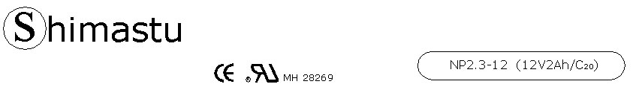

PHYSICAL SPECIFICATION
Nominal Voltage  Nominal Capacity (20HR) |  |  |  | 12V  2Ah |  | 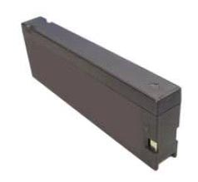
Dimension |  | Length  Width  Container Height  Total Height |  | 182±1mm （7.17ches）  24±1mm (0.94 inches)  61±1mm (2.40 inches)  61±1mm (2.40 inches)
Weight |  |  |  | Approx. 0.76 Kg ( 1.68lbs)
Standard Terminal |  |  |  | Copper
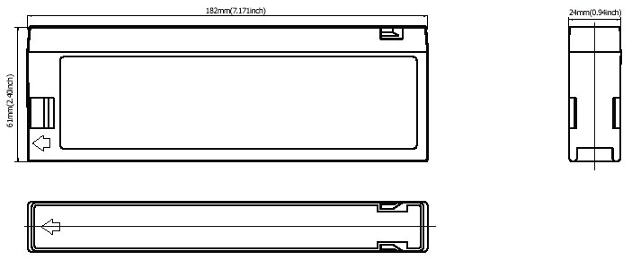 |  |  |  |  |  | 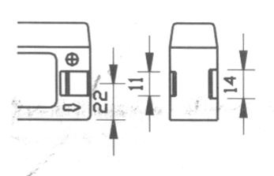

ELECTRICAL SPECIFICATION
Characteristics |  |  |  |  |  | Discharge curves @ 25℃ (77 °F)
Capacity |  |  | 20 hour rate (0.1A)  10 hour rate (0.18A)  5 hour rate (0.34A)  3 hour rate (0.5A)  1hour rate (1.2A) |  | 2Ah  1.9Ah  1.7Ah  1.5Ah  1.2Ah | 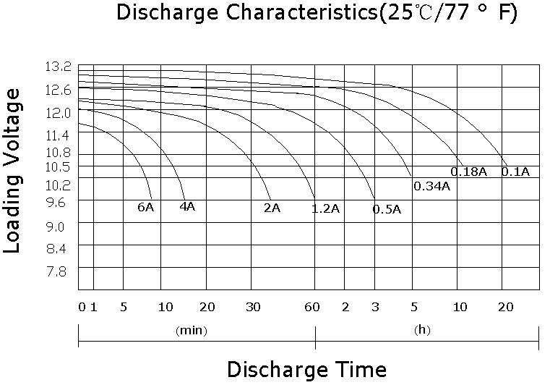
Capacity affected  by temperature |  |  | 40℃ （104 ⁰F）  25℃ （77 ⁰F）  0℃ （32 ⁰F） |  | 102%  100%  85%
Internal Resistance |  |  | Full charged battery (25℃,77 ⁰F) 50mΩ
Constant Voltage  Charge | Cycle |  | Initial Charging Current less than 0.69A  Voltage 14.4~15.0V at 25℃ (77 ⁰F )  Temperature Coefficient –30mV/℃
Constant Voltage  Charge | Standby |  | No limit on Initial Charging Current  Voltage 13.5~13.8V at 25℃ (77 ⁰F )  Temperature Coefficient –20mV/℃
(In mm)

