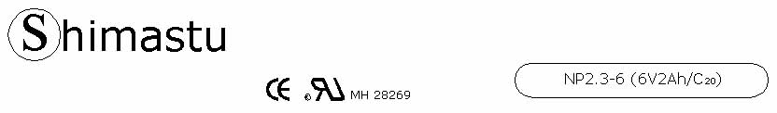

PHYSICAL SPECIFICATION
Nominal Voltage  Nominal Capacity (20HR) |  |  |  | 6V  2Ah |  |  | 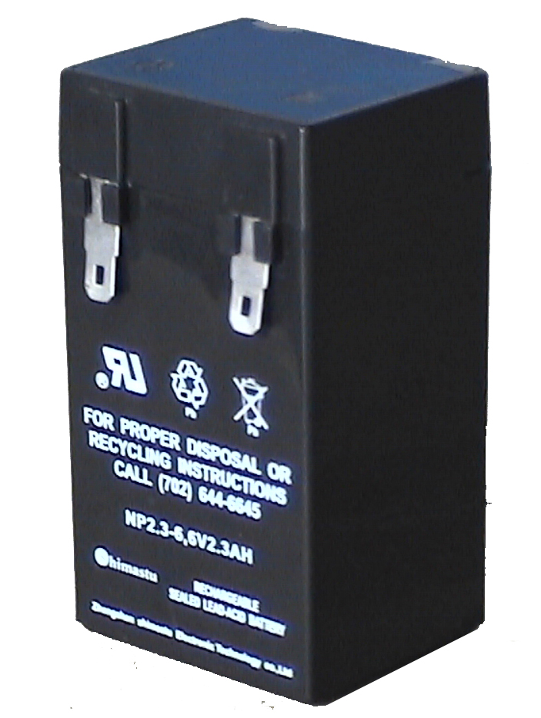
Dimension |  | Length  Width  Container Height  Total Height |  | 42±1mm （1.65 inches)  37±1mm (1.46 inches)  76±1mm (2.99 inches)  76±1mm (2.99 inches)
Weight |  |  |  | Approx. 0.33Kg ( 0.73lbs)
Standard Terminal |  |  |  | Copper
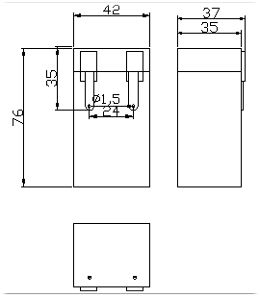 |  |  |  |  |  |  | 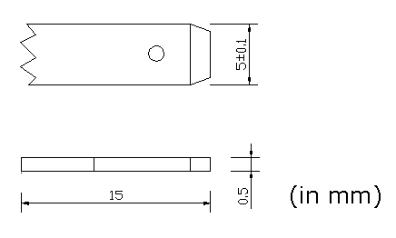

ELECTRICAL SPECIFICATION
Characteristics |  |  |  |  |  |  | Discharge curves @ 25℃ (77 °F)
Capacity |  |  | 20 hour rate (100mA)  10 hour rate (180mA)  5 hour rate (340mA)  3 hour rate (500mA)  1hour rate (1200mA) |  |  | 2Ah  1.9Ah  1.7Ah  1.5Ah  1.2Ah | 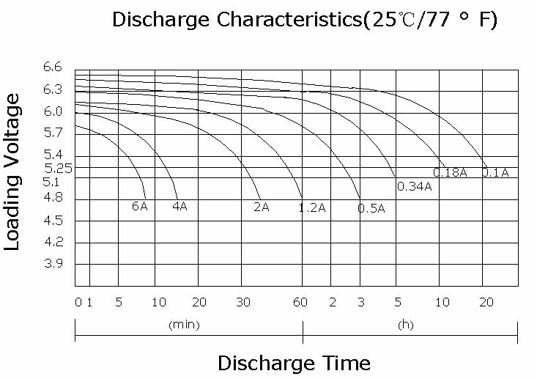
Capacity affected  by temperature |  |  | 40℃ （104 ⁰F）  25℃ （77 ⁰F）  0℃ （32 ⁰F） |  | 102%  100%  85%
Internal Resistance |  |  | Full charged battery (25℃,77 ⁰F) 50mΩ
Constant Voltage  Charge | Cycle |  | Initial Charging Current less than 0.69A  Voltage 7.20~7.50V at 25℃ (77 ⁰F )  Temperature Coefficient –15mV/℃
Constant Voltage  Charge | Standby |  | No limit on Initial Charging Current  Voltage 6.75~6.90V at 25℃ (77 ⁰F )  Temperature Coefficient –10mV/℃

