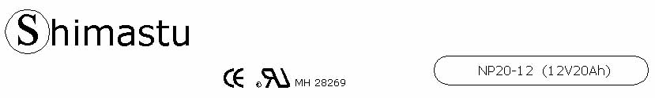

PHYSICAL SPECIFICATION
Nominal Voltage  Nominal Capacity (20HR) |  |  |  | 12V  20Ah |  | 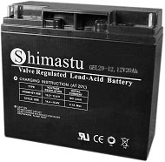
Dimension |  | Length  Width  Container Height  Total Height |  | 181±1mm （7.13 inches)  77±1mm (3.03 inches)  167±1mm (6.57 inches)  167±1mm (6.57 inches)
Weight |  |  |  | Approx. 6.1 Kg (13.44lbs)
Standard Terminal |  |  |  | Bolt and nut terminal  Bolt Type:M5
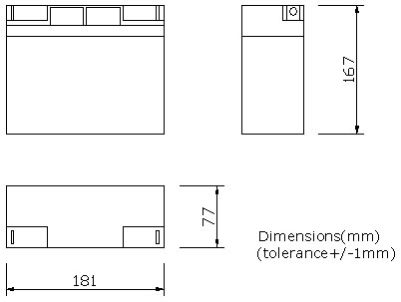 |  |  |  |  |  | 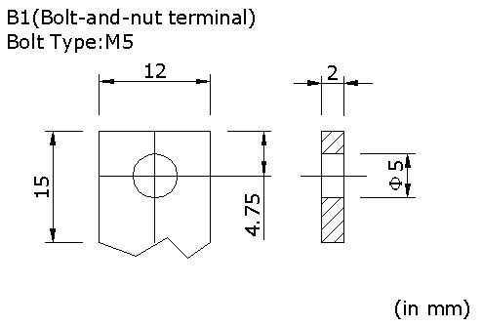

ELECTRICAL SPECIFICATION
Characteristics |  |  |  |  |  | Discharge curves @ 25℃ (77 °F)
Capacity |  |  | 20 hour rate (1A)  10 hour rate (1.8A)  5 hour rate (3.4A)  1hour rate (12A) |  | 20Ah  19Ah  17Ah  16Ah | 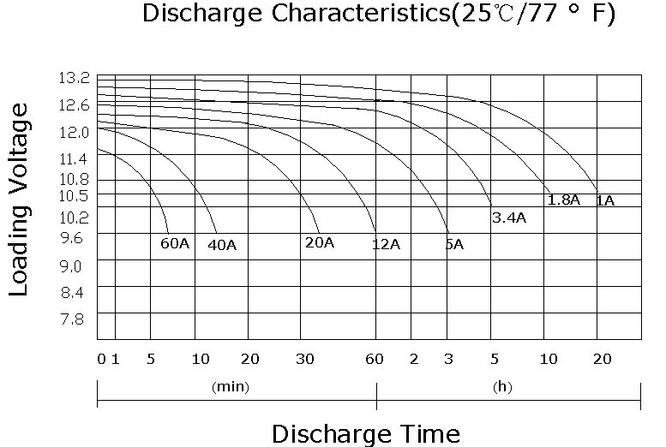
Capacity affected  by temperature |  |  | 40℃ （104 ⁰F）  25℃ （77 ⁰F）  0℃ （32 ⁰F） |  | 92%  84%  75%
Internal Resistance |  |  | Full charged battery (25℃,77 ⁰F) 15mΩ
Constant Voltage  Charge | Cycle |  | Initial Charging Current less than 6A  Voltage 14.4~15.0V at 25℃ (77 ⁰F )  Temperature Coefficient –30mV/℃
Constant Voltage  Charge | Standby |  | No limit on Initial Charging Current  Voltage 13.5~13.8V at 25℃ (77 ⁰F )  Temperature Coefficient –20mV/℃

