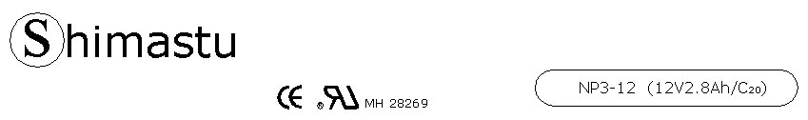

PHYSICAL SPECIFICATION
Nominal Voltage  Nominal Capacity (20HR) |  |  |  | 12V  3Ah |  | 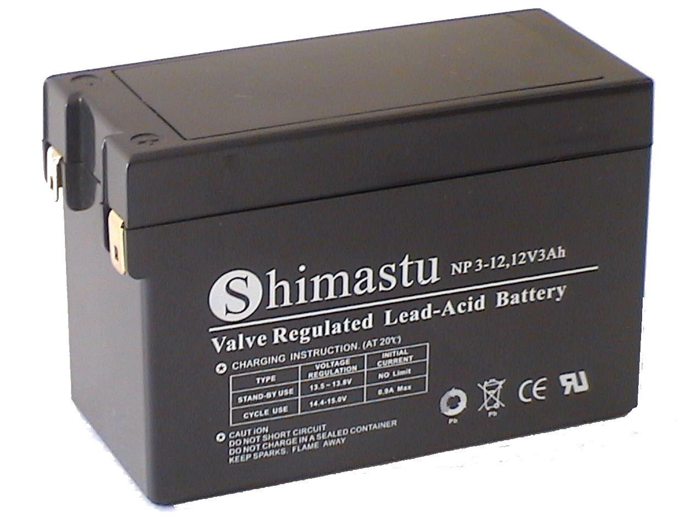
Dimension |  | Length  Width  Container Height  Total Height |  | 104±1mm （4.09 inches）  48±1mm (1.89 inches)  70±1mm (2.76 inches)  70±1mm (2.76 inches)
Weight |  |  |  | Approx. 0.99Kg ( 2.18lbs)
Standard Terminal |  |  |  | Copper
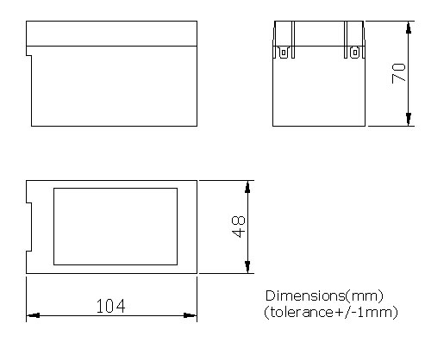 |  |  |  |  |  | 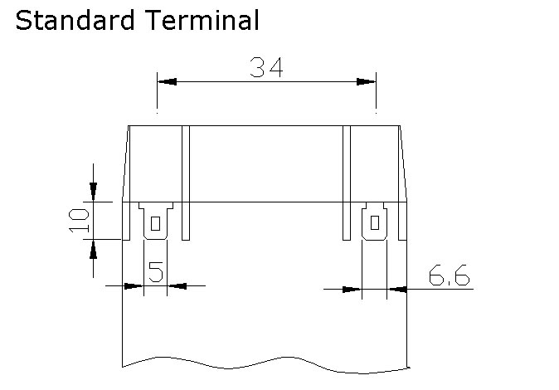

ELECTRICAL SPECIFICATION
Characteristics |  |  |  |  |  | Discharge curves @ 25℃ (77 °F)
Capacity |  |  | 20 hour rate (0.14A)  10 hour rate (0.252A)  5 hour rate (0.476A)  3 hour rate (0.7A)  1hour rate (1.68A) |  | 2.8Ah  2.66Ah  2.38Ah  2.1Ah  1.68Ah | 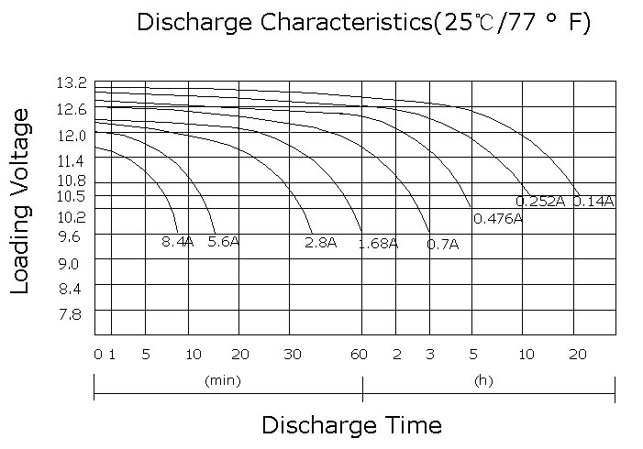
Capacity affected  by temperature |  |  | 40℃ （104 ⁰F）  25℃ （77 ⁰F）  0℃ （32 ⁰F） |  | 102%  100%  85%
Internal Resistance |  |  | Full charged battery (25℃,77 ⁰F) 35mΩ
Constant Voltage  Charge | Cycle |  | Initial Charging Current less than 0.9A  Voltage 14.4~15.0V at 25℃ (77 ⁰F )  Temperature Coefficient –15mV/℃
Constant Voltage  Charge | Standby |  | No limit on Initial Charging Current  Voltage 13.5~13.8V at 25℃ (77 ⁰F )  Temperature Coefficient –10mV/℃

