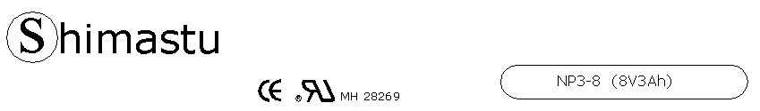

PHYSICAL SPECIFICATION
Nominal Voltage  Nominal Capacity (20HR) |  |  |  | 8V  3Ah |  | 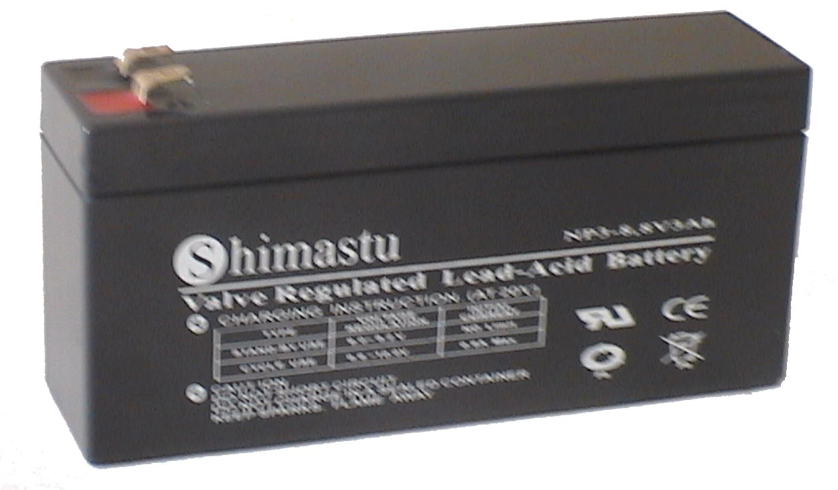
Dimension |  | Length  Width  Container Height  Total Height |  | 134±1mm (5.28 inches)  36±1mm (1.42 inches)  64±1mm (2.52 inches)  69±1mm (2.72 inches)
Weight |  |  |  | Approx. 0.84 Kg ( 1.85lbs)
Standard Terminal |  |  |  | Fasten Tab No.187E
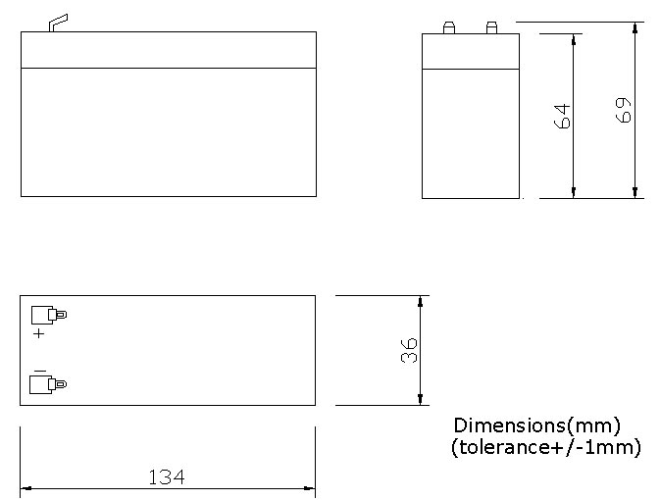 |  |  |  |  |  | 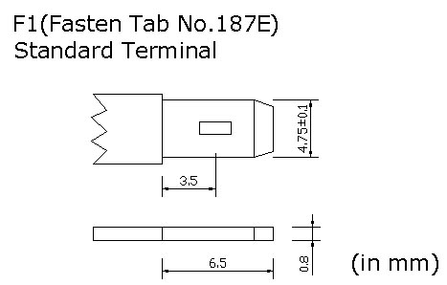

ELECTRICAL SPECIFICATION
Characteristics |  |  |  |  |  | Discharge curves @ 25℃ (77 °F)
Capacity |  |  | 20 hour rate (0.15A)  10 hour rate (0.27A)  5 hour rate (0.51A)  3 hour rate (0.75A)  1hour rate (1.8A) |  | 3Ah  2.85Ah  2.55Ah  2.25Ah  1.8Ah | 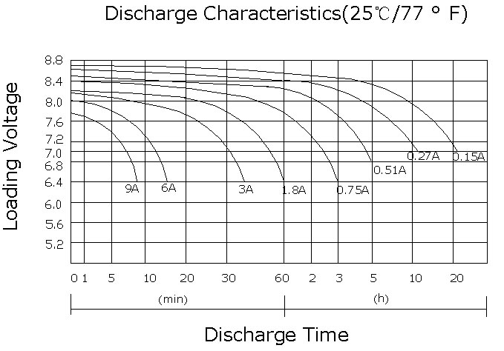
Capacity affected  by temperature |  |  | 40℃ （104 ⁰F）  25℃ （77 ⁰F）  0℃ （32 ⁰F） |  | 102%  100%  85%
Internal Resistance |  |  | Full charged battery (25℃,77 ⁰F) 25mΩ
Constant Voltage  Charge | Cycle |  | Initial Charging Current less than 0.9A  Voltage 9.6~10V at 25℃ (77 ⁰F )  Temperature Coefficient –18mV/℃
Constant Voltage  Charge | Standby |  | No limit on Initial Charging Current  Voltage 9~9.2V at 25℃ (77 ⁰F )  Temperature Coefficient –18mV/℃

