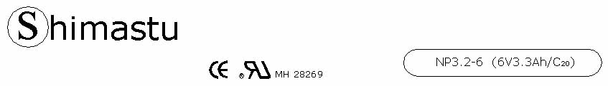

PHYSICAL SPECIFICATION
Nominal Voltage  Nominal Capacity (20HR) |  |  |  | 6V  3.3Ah |  | 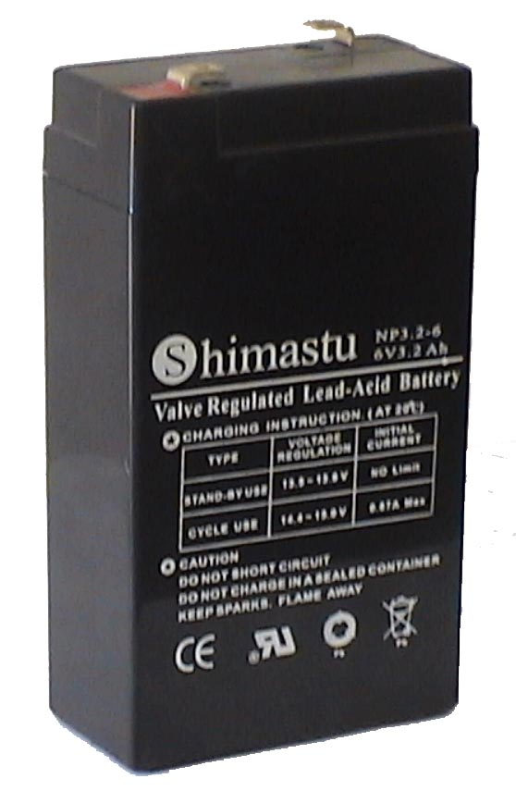
Dimension |  | Length  Width  Container Height  Total Height |  | 66±1mm (5.28 inches)  34±1mm (1.34 inches)  115±1mm (2.44 inches)  120±1mm (2.68 inches)
Weight |  |  |  | Approx. 0.63Kg ( 1.39lbs)
Standard Terminal |  |  |  | Fasten Tab No.187E
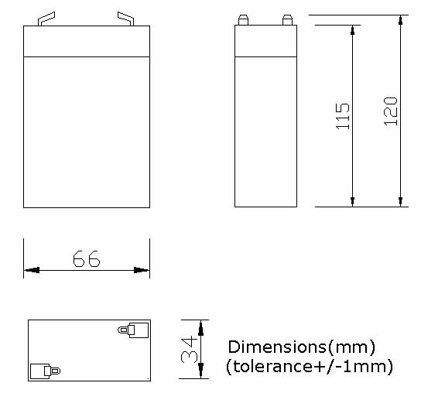 |  |  |  |  |  | 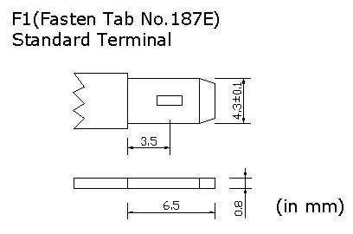

ELECTRICAL SPECIFICATION
Characteristics |  |  |  |  |  |  | Discharge curves @ 25℃ (77 °F)
Capacity |  |  | 20 hour rate (0.165A)  10 hour rate (0.297A)  5 hour rate (0.561A)  3 hour rate (0.825A)  1hour rate (1.98A) |  | 3.3Ah  3.1Ah  2.9Ah  2.5Ah  2Ah |  | 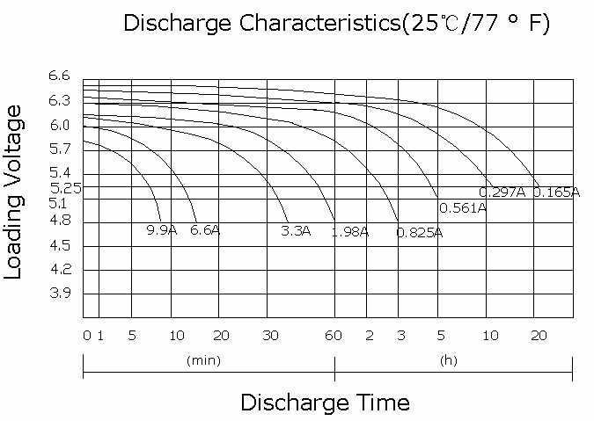
Capacity affected  by temperature |  |  | 40℃ （104 ⁰F）  25℃ （77 ⁰F）  0℃ （32 ⁰F） |  | 102%  100%  85%
Internal Resistance |  |  | Full charged battery (25℃,77 ⁰F) 25mΩ
Constant Voltage  Charge | Cycle |  | Initial Charging Current less than 0.96A  Voltage 7.20~7.50V at 25℃ (77 ⁰F )  Temperature Coefficient –15mV/℃
Constant Voltage  Charge | Standby |  | No limit on Initial Charging Current  Voltage 6.75~6.90V at 25℃ (77 ⁰F )  Temperature Coefficient –10mV/℃

