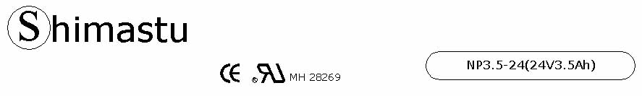

PHYSICAL SPECIFICATION
Nominal Voltage  Nominal Capacity (20HR) |  |  |  | 24V  3.5Ah |  | 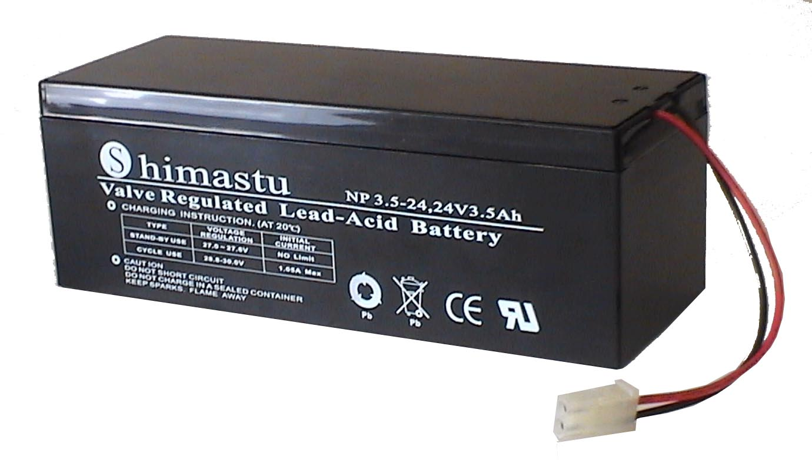
Dimension |  | Length  Width  Container Height  Total Height |  | 206±1mm （3.82 inches）  77±1mm (1.73 inches)  74±1mm (2.09 inches)  74±1mm (2.32 inches)
Weight |  |  |  | Approx. 2.84 Kg ( 6.26lbs)
Standard Terminal |  |  |  | Wire and Connector Type
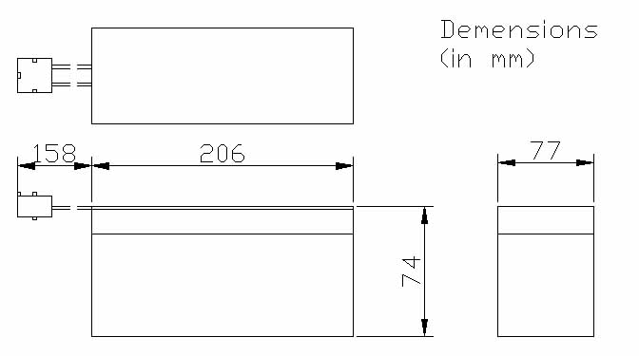 |  |  |  |  |  | 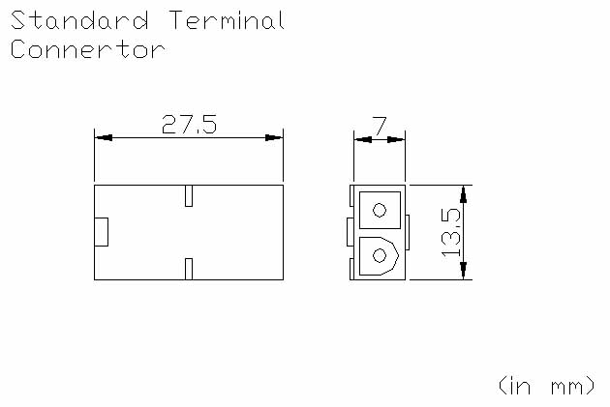

ELECTRICAL SPECIFICATION
Characteristics |  |  |  |  |  | Discharge curves @ 25℃ (77 °F)
Capacity |  |  | 20 hour rate (0.175A)  10 hour rate (0.315A)  5 hour rate (0.595A)  3 hour rate (0.875A)  1hour rate (0.72A) |  | 3.5Ah  3.3Ah  3Ah  2.7Ah  2.1Ah | 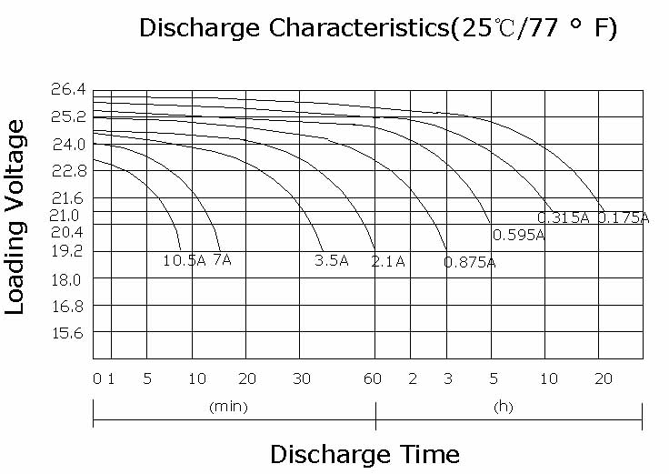
Capacity affected  by temperature |  |  | 40℃ （104 ⁰F）  25℃ （77 ⁰F）  0℃ （32 ⁰F） |  | 102%  100%  85%
Internal Resistance |  |  | Full charged battery (25℃,77 ⁰F) 50mΩ
Constant Voltage  Charge | Cycle |  | Initial Charging Current less than 1.05A  Voltage 28.8~30V at 25℃ (77 ⁰F )  Temperature Coefficient –60mV/℃
Constant Voltage  Charge | Standby |  | No limit on Initial Charging Current  Voltage 27~27.6V at 25℃ (77 ⁰F )  Temperature Coefficient –40mV/℃

