

PHYSICAL SPECIFICATION
Nominal Voltage  Nominal Capacity (10HR) |  |  |  | 6V  300Ah |  | 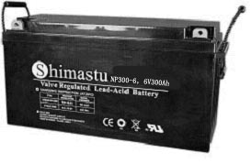
Dimension |  | Length  Width  Container Height  Total Height |  | 485±2mm （19.09 inches）  172±2mm (6.77 inches)  240±2mm (9.45 inches)  240±2mm (9.45 inches)
Weight |  |  |  | Approx. 42 Kg ( 92.57lbs)
Standard Terminal |  |  |  | Bolt-and-nut lead terminal  Bolt Type: M8
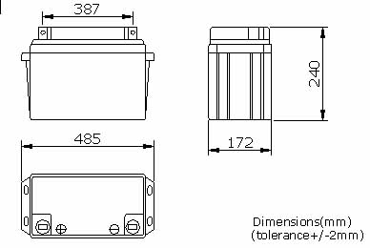 |  |  |  |  |  | 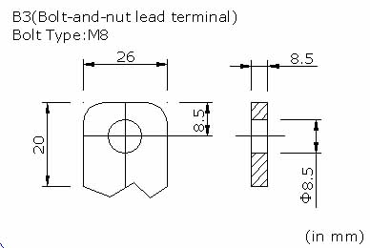

ELECTRICAL SPECIFICATION
Characteristics |  |  |  |  |  | Discharge curves @ 25℃ (77 °F)
Capacity |  |  | 10 hour rate (30A)  5 hour rate (51A)  3 hour rate (75A)  1hour rate (180A) |  | 300Ah  255Ah  225Ah  180Ah | 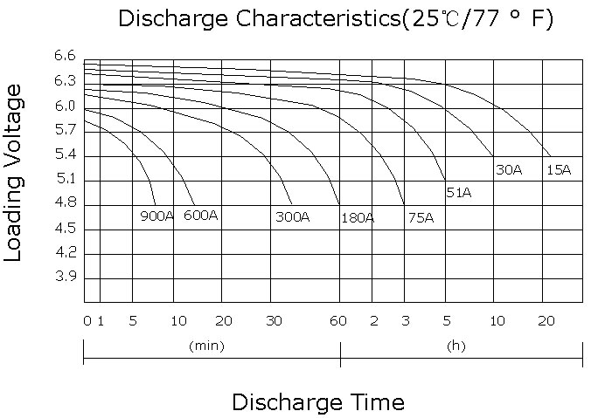
Capacity affected  by temperature |  |  | 40℃ （104 ⁰F）  25℃ （77 ⁰F）  0℃ （32 ⁰F） |  | 102%  100%  85%
Internal Resistance |  |  | Full charged battery (25℃,77 ⁰F) 3mΩ
Constant Voltage  Charge | Cycle |  | Initial Charging Current less than 75A  Voltage 7.05~7.2V at 25℃ (77 ⁰F )  Temperature Coefficient –15mV/℃
Constant Voltage  Charge | Standby |  | No limit on Initial Charging Current  Voltage 6.75~6.9V at 25℃ (77 ⁰F )  Temperature Coefficient –10mV/℃

