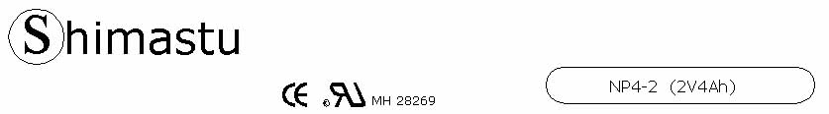

PHYSICAL SPECIFICATION
Nominal Voltage  Nominal Capacity (20HR) |  |  |  | 2V  4Ah |  | 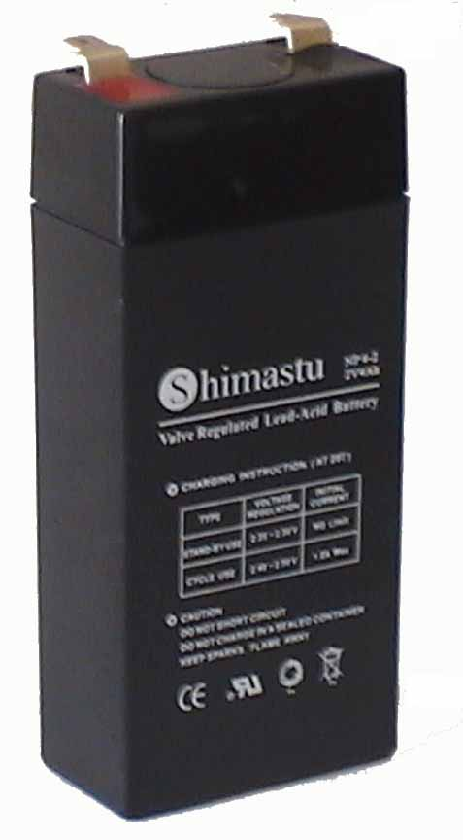
Dimension |  | Length  Width  Container Height  Total Height |  | 46±1mm (1.81 inches)  25±1mm (0.98 inches)  100±1mm (3.94 inches)  105±1mm (4.13 inches)
Weight |  |  |  | Approx. 0.27 Kg ( 0.60lbs)
Standard Terminal |  |  |  | Fasten Tab No.187E
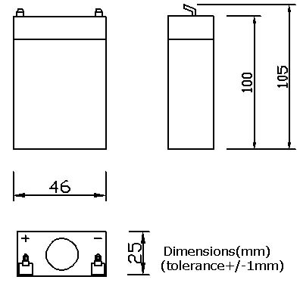 |  |  |  |  |  | 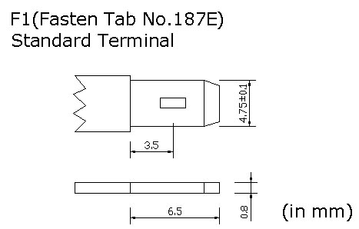

ELECTRICAL SPECIFICATION
Characteristics |  |  |  |  |  | Discharge curves @ 25℃ (77 °F)
Capacity |  |  | 20 hour rate (0.2A)  10 hour rate (0.36A)  5 hour rate (0.68A)  3 hour rate (1A)  1hour rate (2.4A) |  | 4Ah  3.8Ah  3.4Ah  3Ah  2.4Ah | 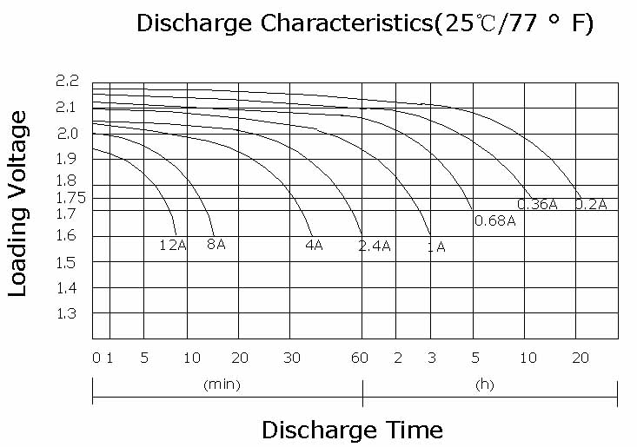
Capacity affected  by temperature |  |  | 40℃ （104 ⁰F）  25℃ （77 ⁰F）  0℃ （32 ⁰F） |  | 102%  100%  85%
Internal Resistance |  |  | Full charged battery (25℃,77 ⁰F) 5mΩ
Constant Voltage  Charge | Cycle |  | Initial Charging Current less than 1.2A  Voltage 2.4~2.5V at 25℃ (77 ⁰F )  Temperature Coefficient –18mV/℃
Constant Voltage  Charge | Standby |  | No limit on Initial Charging Current  Voltage 2.25~2.3V at 25℃ (77 ⁰F )  Temperature Coefficient –18mV/℃

