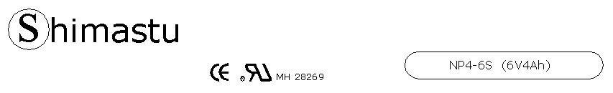

PHYSICAL SPECIFICATION
Nominal Voltage  Nominal Capacity (20HR) |  |  |  | 6V  4Ah |  | 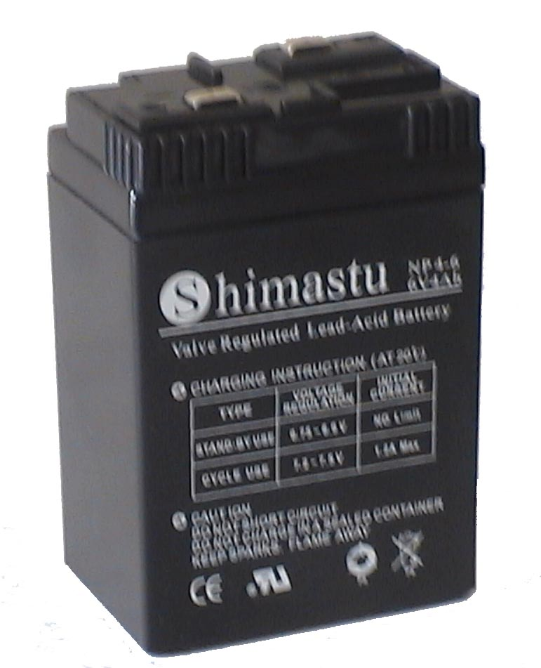
Dimension |  | Length  Width  Container Height  Total Height |  | 71±1mm （2.80 inches)  47±1mm (1.85 inches)  103±1mm (4.06 inches)  104±1mm (4.09 inches)
Weight |  |  |  | Approx. 0.73Kg ( 1.61lbs)
Standard Terminal |  |  |  | Copper
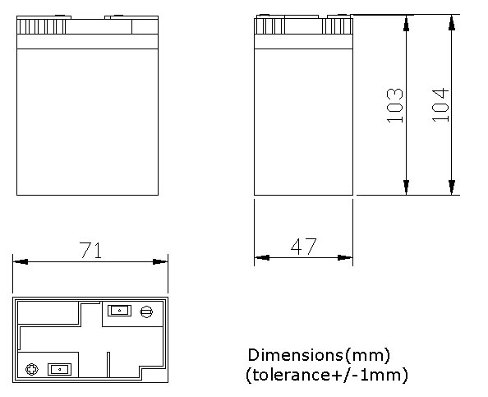 |  |  |  |  |  | 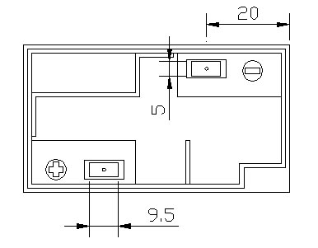

ELECTRICAL SPECIFICATION
Characteristics |  |  |  |  |  | Discharge curves @ 25℃ (77 °F)
Capacity |  |  | 20 hour rate (0.2A)  10 hour rate (0.36A)  5 hour rate (0.68A)  3 hour rate (1A)  1hour rate (2.4A) |  | 4Ah  3.8Ah  3.4Ah  3Ah  2.4Ah | 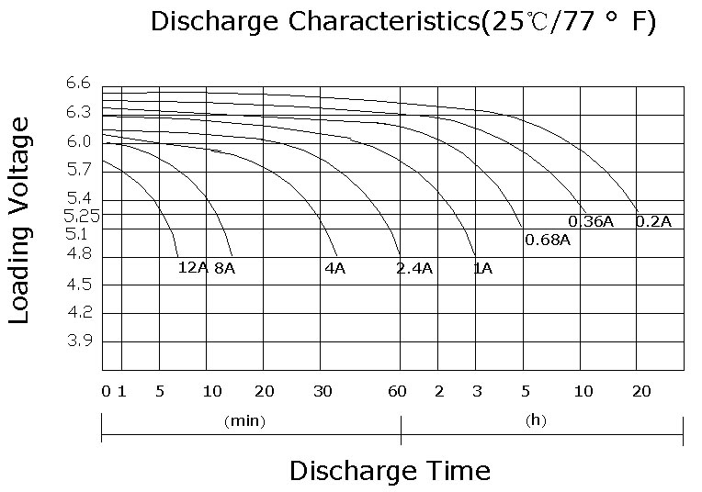
Capacity affected  by temperature |  |  | 40℃ （104 ⁰F）  25℃ （77 ⁰F）  0℃ （32 ⁰F） |  | 102%  100%  85%
Internal Resistance |  |  | Full charged battery (25℃,77 ⁰F) 25mΩ
Constant Voltage  Charge | Cycle |  | Initial Charging Current less than 1.2A  Voltage 7.20~7.50V at 25℃ (77 ⁰F )  Temperature Coefficient –15mV/℃
Constant Voltage  Charge | Standby |  | No limit on Initial Charging Current  Voltage 6.75~6.90V at 25℃ (77 ⁰F )  Temperature Coefficient –10mV/℃

