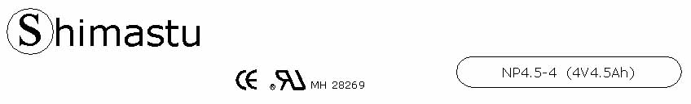

PHYSICAL SPECIFICATION
Nominal Voltage  Nominal Capacity (20HR) |  |  |  | 4V  4.5Ah |  | 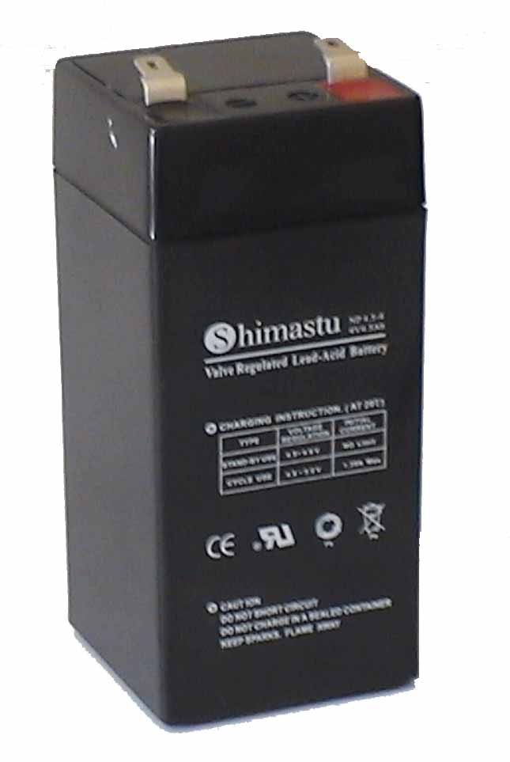
Dimension |  | Length  Width  Container Height  Total Height |  | 47±1mm (1.85 inches)  47±1mm (1.85 inches)  101±1mm (3.98 inches)  106±1mm (4.17 inches)
Weight |  |  |  | Approx. 0.6Kg (1.32lbs)
Standard Terminal |  |  |  | Fasten Tab No.187E
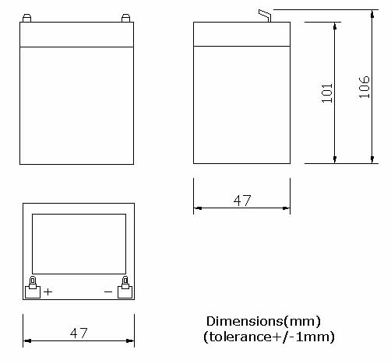 |  |  |  |  |  | 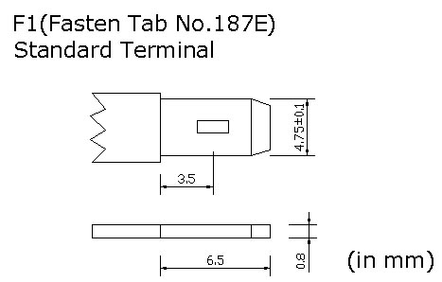

ELECTRICAL SPECIFICATION
Characteristics |  |  |  |  |  | Discharge curves @ 25℃ (77 °F)
Capacity |  |  | 20 hour rate (0.225A)  10 hour rate (0.405A)  5 hour rate (0.765A)  3 hour rate (1.125A)  1hour rate (2.7A) |  | 4.5Ah  4.2Ah  3.9Ah  3.4Ah  2.7Ah | 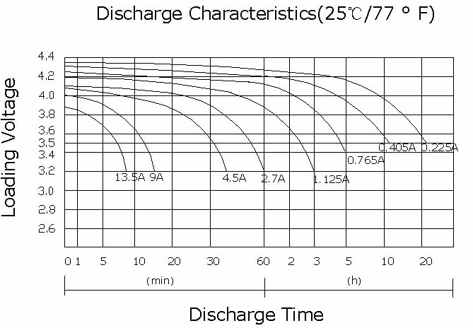
Capacity affected  by temperature |  |  | 40℃ （104 ⁰F）  25℃ （77 ⁰F）  0℃ （32 ⁰F） |  | 102%  100%  85%
Internal Resistance |  |  | Full charged battery (25℃,77 ⁰F) 20mΩ
Constant Voltage  Charge | Cycle |  | Initial Charging Current less than 1.35A  Voltage 4.8~5V at 25℃ (77 ⁰F )  Temperature Coefficient –18mV/℃
Constant Voltage  Charge | Standby |  | No limit on Initial Charging Current  Voltage 4.5~4.6V at 25℃ (77 ⁰F )  Temperature Coefficient –18mV/℃

