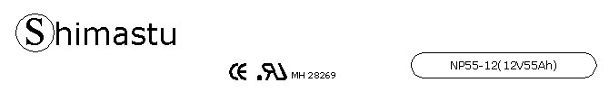

PHYSICAL SPECIFICATION
Nominal Voltage  Nominal Capacity (10HR) |  |  |  | 12V  55Ah |  | 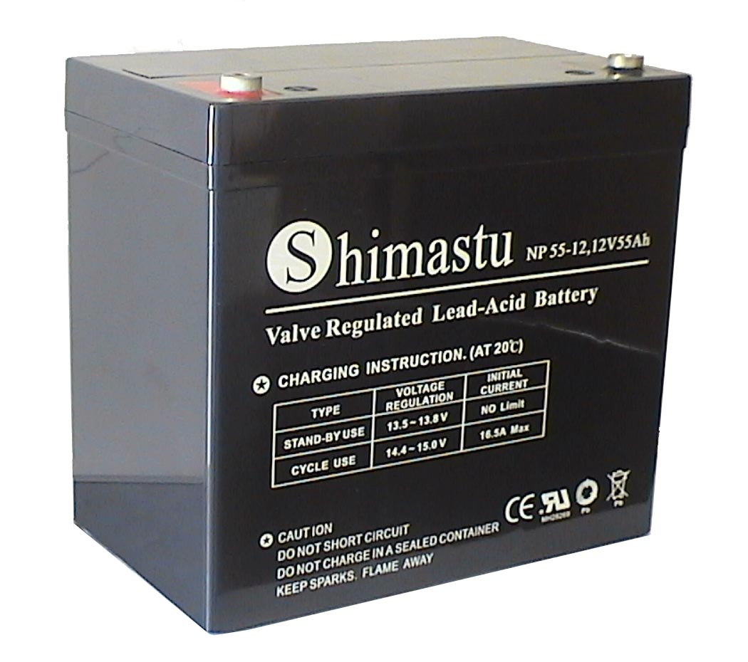
Dimension |  | Length  Width  Container Height  Total Height |  | 229±2mm （9.02 inches）  138±2mm (5.43 inches)  208±2mm (8.19 inches)  213±2mm (8.39 inches)
Weight |  |  |  | Approx. 17.2 Kg ( 37.91lbs)
Standard Terminal |  |  |  | Bolt-and-nut terminal  Bolt Type: M6
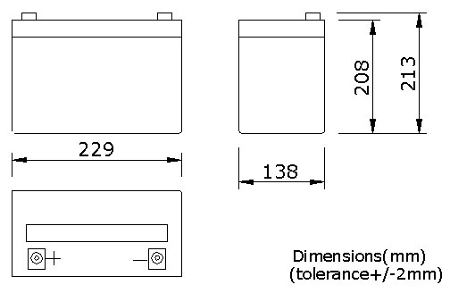 |  |  |  |  |  | 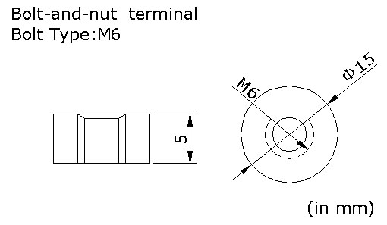

ELECTRICAL SPECIFICATION
Characteristics |  |  |  |  |  | Discharge curves @ 25℃ (77 °F)
Capacity |  |  | 10 hour rate (5.5A)  5 hour rate (9.35A)  3 hour rate (13.75A)  1hour rate (33A) |  | 55Ah  46.8Ah  41.3Ah  33Ah | 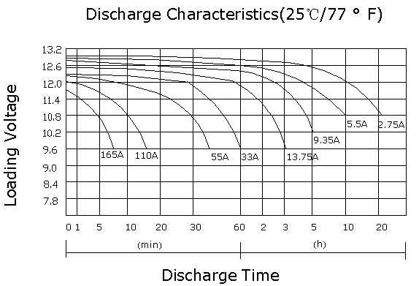
Capacity affected  by temperature |  |  | 40℃ （104 ⁰F）  25℃ （77 ⁰F）  0℃ （32 ⁰F） |  | 102%  100%  85%
Internal Resistance |  |  | Full charged battery (25℃,77 ⁰F) 6mΩ
Constant Voltage  Charge | Cycle |  | Initial Charging Current less than 13.7A  Voltage 14.1~14.4V at 25℃ (77 ⁰F )  Temperature Coefficient –18mV/℃
Constant Voltage  Charge | Standby |  | No limit on Initial Charging Current  Voltage 13.5~13.8V at 25℃ (77 ⁰F )  Temperature Coefficient –18mV/℃

