

PHYSICAL SPECIFICATION
Nominal Voltage  Nominal Capacity (20HR) |  |  |  | 12V  65Ah |  | 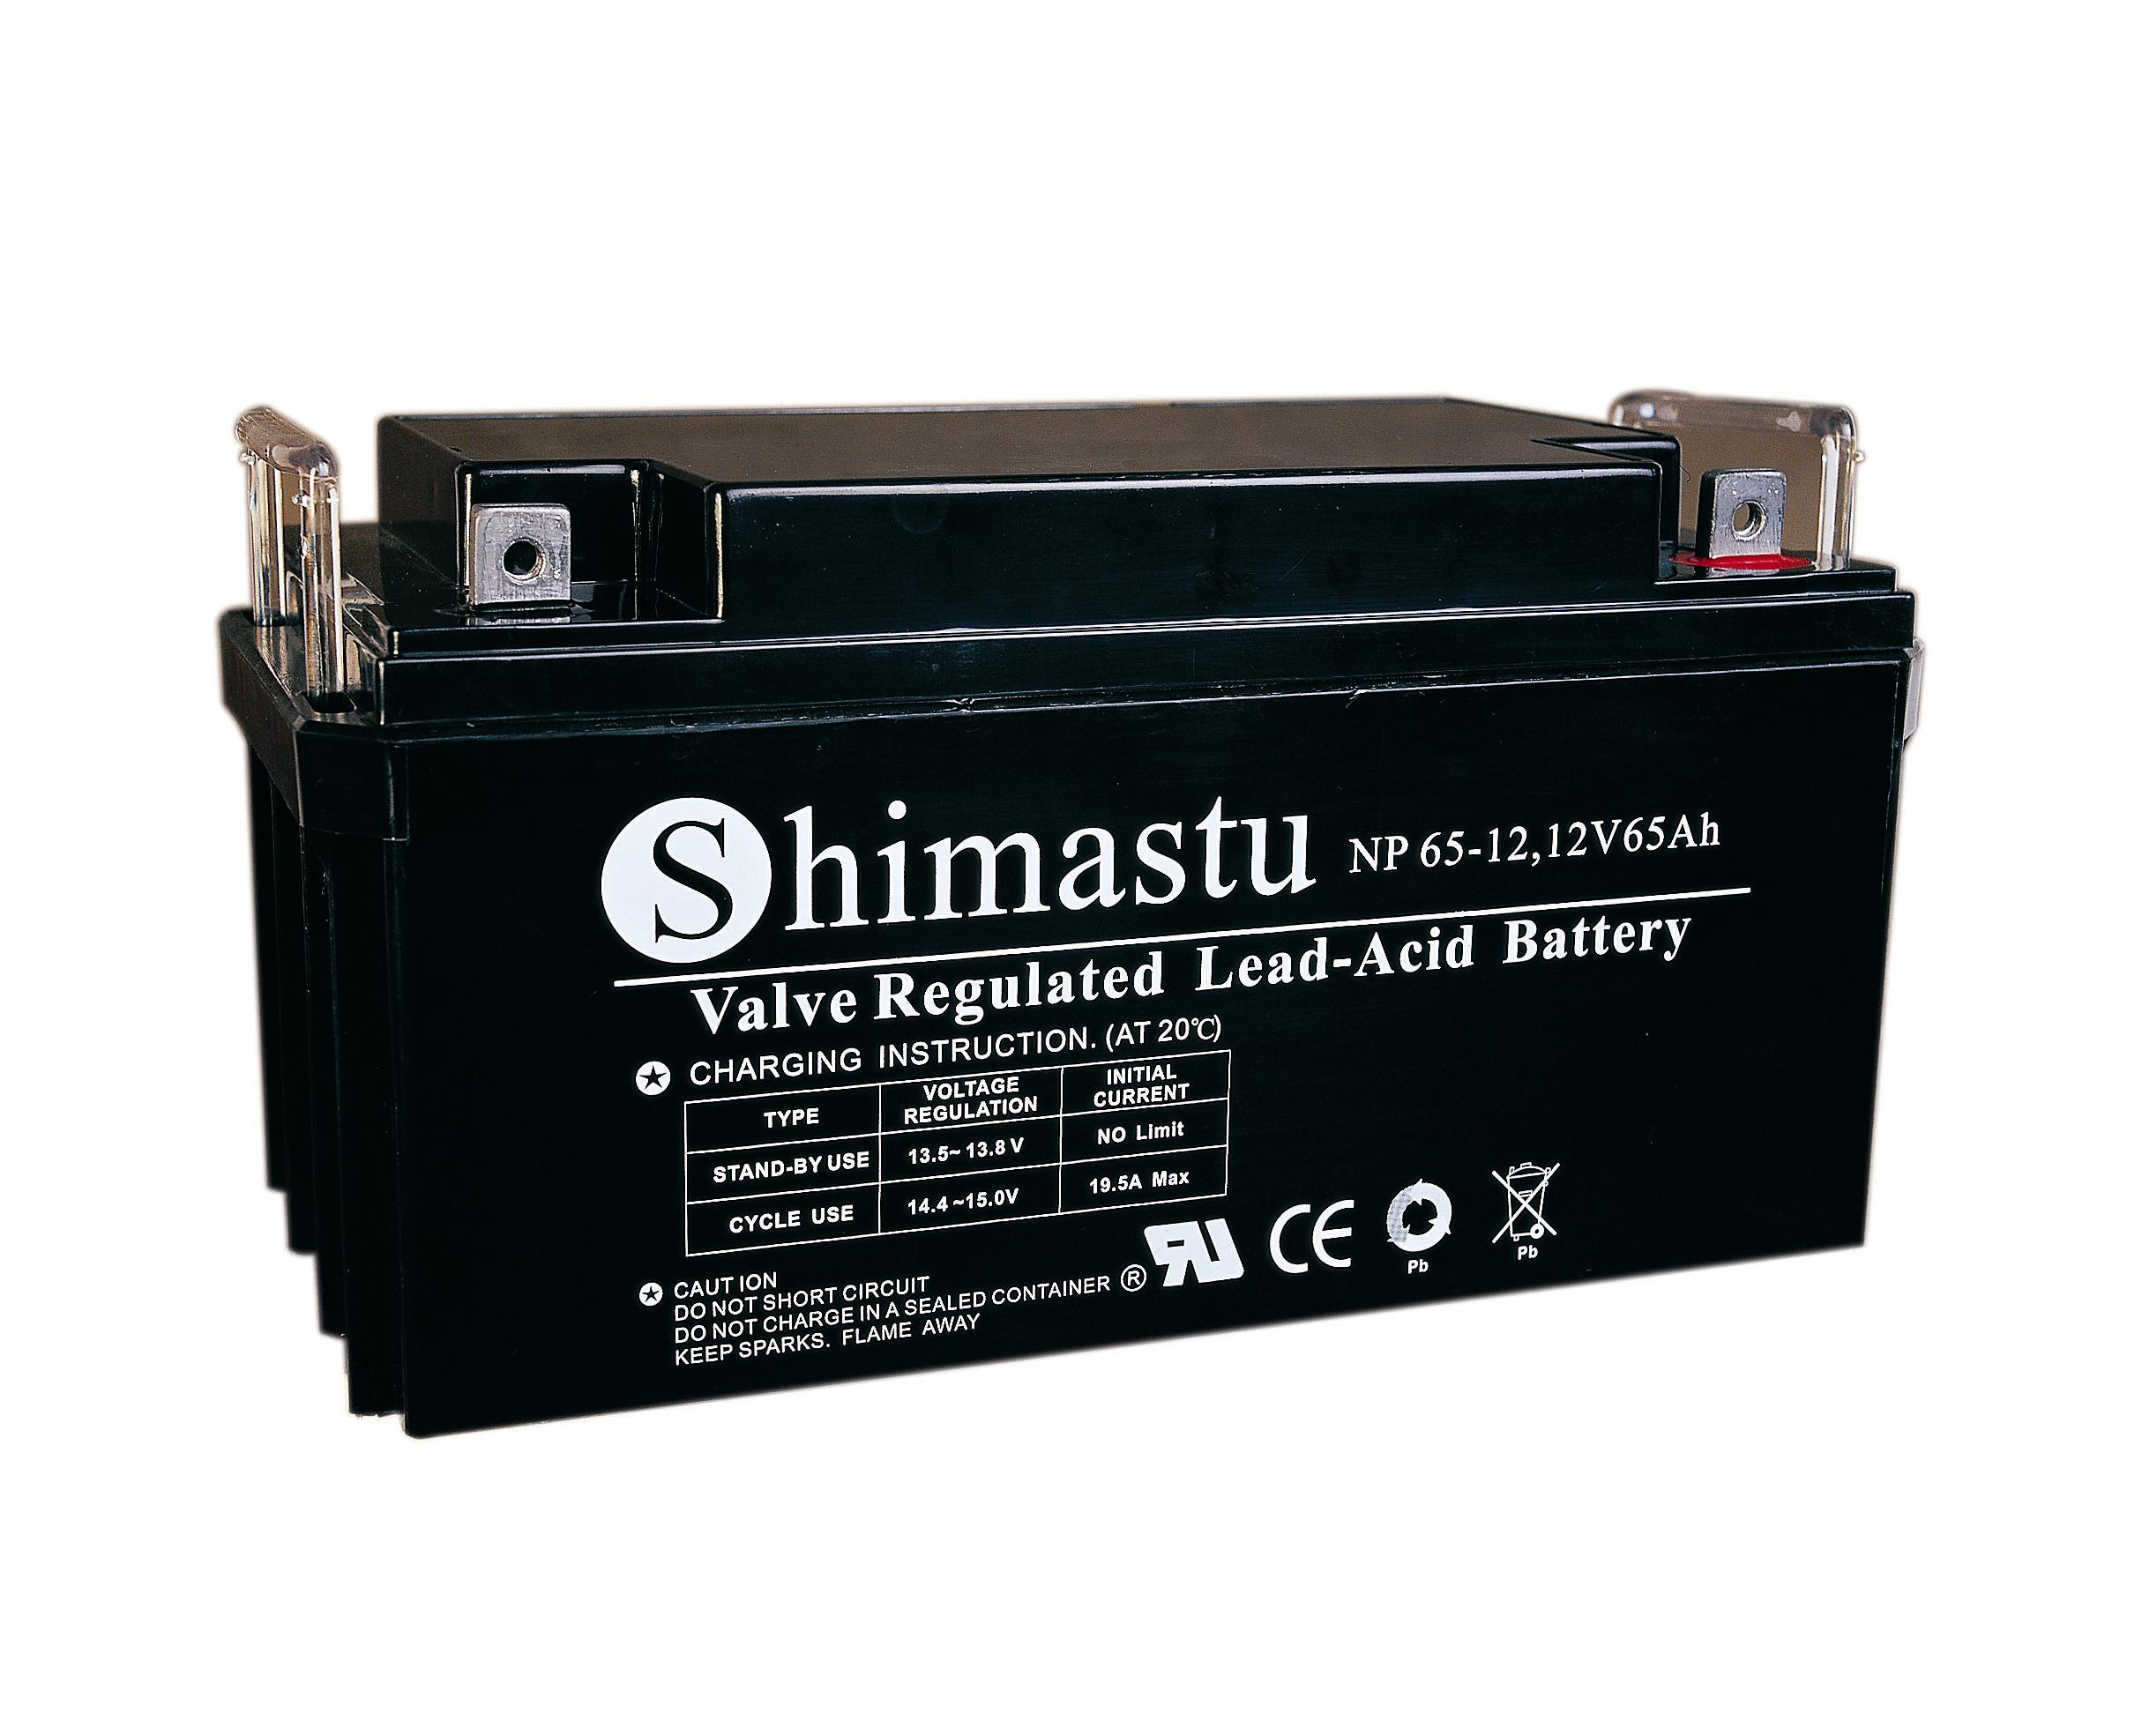
Dimension |  | Length  Width  Container Height  Total Height |  | 350±1mm （13.78 inches）  167±1mm (6.57 inches)  178±1mm (7.01 inches)  178±1mm (7.01 inches)
Weight |  |  |  | Approx. 21Kg ( 46.28lbs)
Standard Terminal |  |  |  | Bolt-and-nut lead terminal  Bolt Type: M6
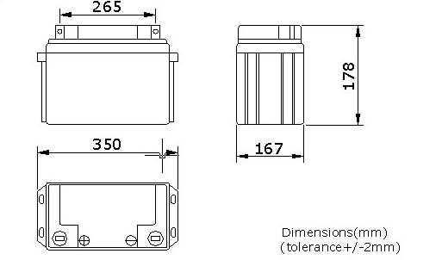 |  |  |  |  |  | 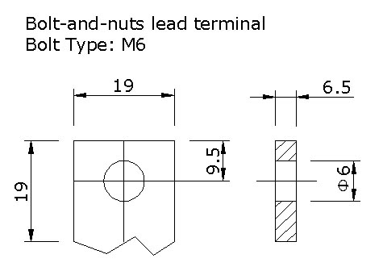

ELECTRICAL SPECIFICATION
Capacity |  |  | 10 hour rate (6.5A)  5 hour rate (11.05A)  3 hour rate (16.25A)  1hour rate (39A) |  | 65Ah  55.5Ah  48.8Ah  39Ah | Discharge curves @ 25℃ (77 °F)
 |  |  |  |  | 65Ah  55.5Ah  48.8Ah  39Ah | 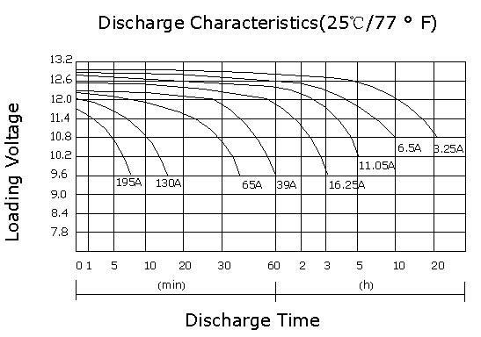
Capacity affected  by temperature |  |  | 40℃ （104 ⁰F）  25℃ （77 ⁰F）  0℃ （32 ⁰F） |  | 102%  100%  85%
Internal Resistance |  |  | Full charged battery (25℃,77 ⁰F) 5mΩ
Constant Voltage  Charge | Cycle |  | Initial Charging Current less than 16.2A  Voltage 14.1~14.4V at 25℃ (77 ⁰F )  Temperature Coefficient –18mV/℃
Constant Voltage  Charge | Standby |  | No limit on Initial Charging Current  Voltage 13.5~13.8V at 25℃ (77 ⁰F )  Temperature Coefficient –18mV/℃

