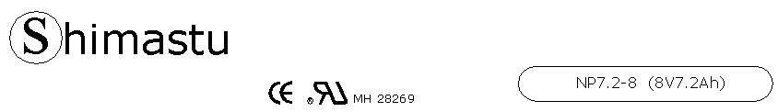

PHYSICAL SPECIFICATION
Nominal Voltage  Nominal Capacity (20HR) |  |  |  | 8V  7.2Ah |  | 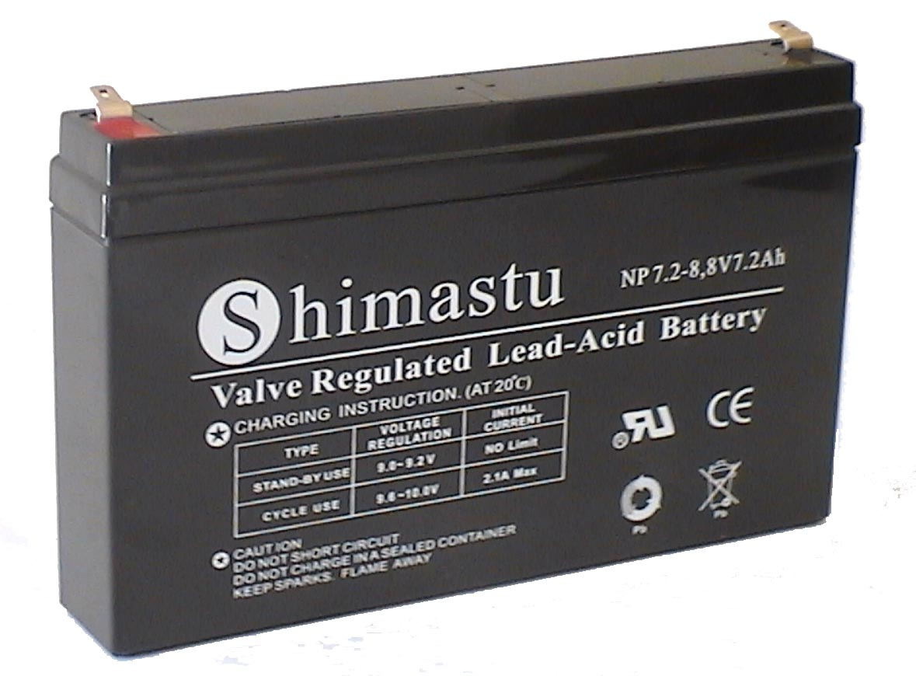
Dimension |  | Length  Width  Container Height  Total Height |  | 164±1mm (6.46 inches)  28±1mm (1.10 inches)  99±1mm (3.90 inches)  104±1mm (4.09 inches)
Weight |  |  |  | Approx. 1.32 Kg ( 2.91lbs)
Standard Terminal |  |  |  | Fasten Tab No.187E
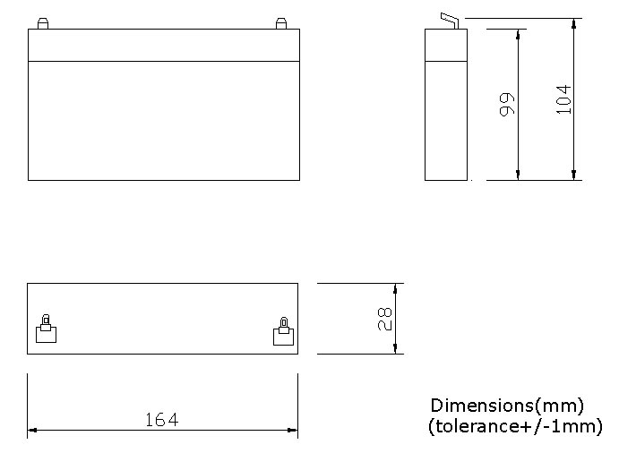 |  |  |  |  |  | 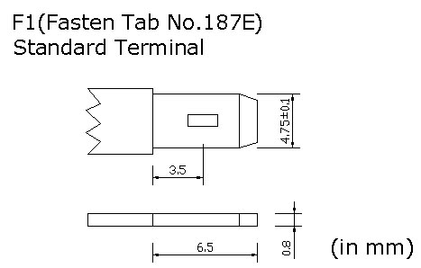

ELECTRICAL SPECIFICATION
Characteristics |  |  |  |  |  | Discharge curves @ 25℃ (77 °F)
Capacity |  |  | 20 hour rate (0.36A)  10 hour rate (0.648A)  5 hour rate (1.224A)  3 hour rate (1.8A)  1hour rate (4.32A) |  | 7.2Ah  6.8Ah  6.2Ah  5.4Ah  4.4Ah | 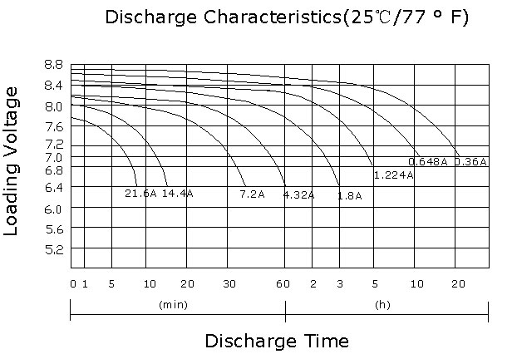
Capacity affected  by temperature |  |  | 40℃ （104 ⁰F）  25℃ （77 ⁰F）  0℃ （32 ⁰F） |  | 102%  100%  85%
Internal Resistance |  |  | Full charged battery (25℃,77 ⁰F) 20mΩ
Constant Voltage  Charge | Cycle |  | Initial Charging Current less than 2.1A  Voltage 9.6~10V at 25℃ (77 ⁰F )  Temperature Coefficient –18mV/℃
Constant Voltage  Charge | Standby |  | No limit on Initial Charging Current  Voltage 9~9.2V at 25℃ (77 ⁰F )  Temperature Coefficient –18mV/℃

