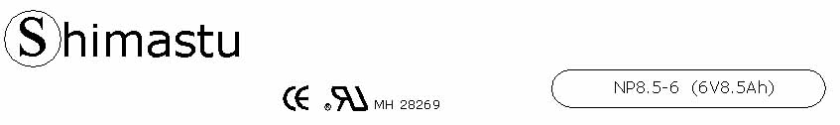

PHYSICAL SPECIFICATION
Nominal Voltage  Nominal Capacity (20HR) |  |  |  | 6V  8.5Ah |  | 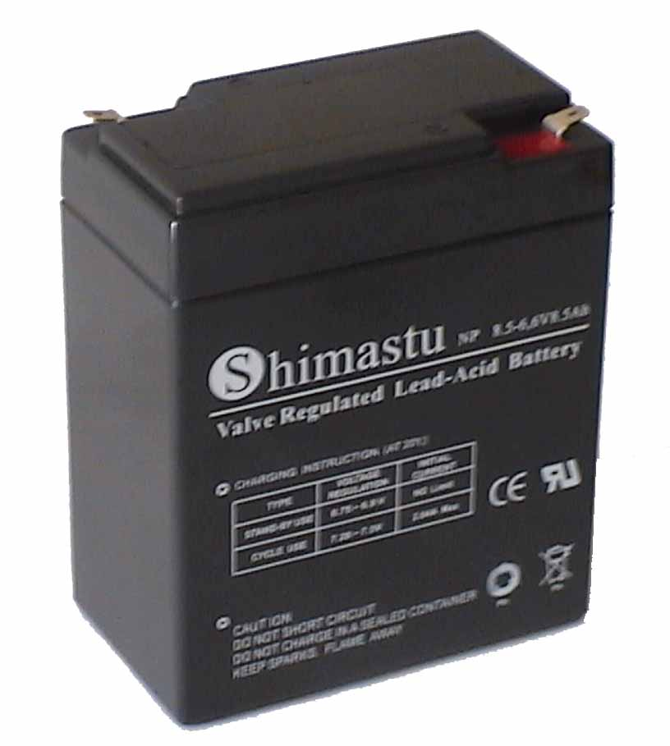
Dimension |  | Length  Width  Container Height  Total Height |  | 150±1mm （5.91 inches)  34±1mm (1.34 inches)  95±1mm (3.74 inches)  101±1mm (3.98 inches)
Weight |  |  |  | Approx. 1.55Kg ( 3.42lbs)
Standard Terminal |  |  |  | Fasten Tab No.187E
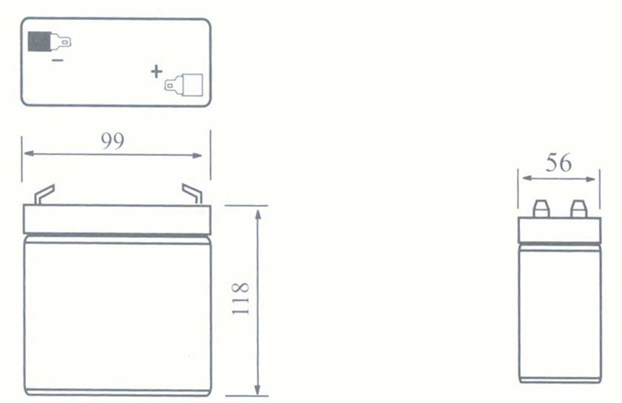 |  |  |  |  |  | 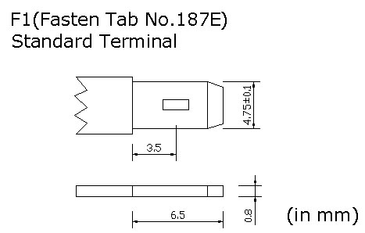

ELECTRICAL SPECIFICATION
Characteristics |  |  |  |  |  | Discharge curves @ 25℃ (77 °F)
Capacity |  |  | 20 hour rate (0.425A)  10 hour rate (0.765A)  5 hour rate (1.445A)  3 hour rate (2.125A)  1hour rate (5.1A) |  | 8.5Ah  8.0Ah  7.5Ah  6.4Ah  5.1Ah | 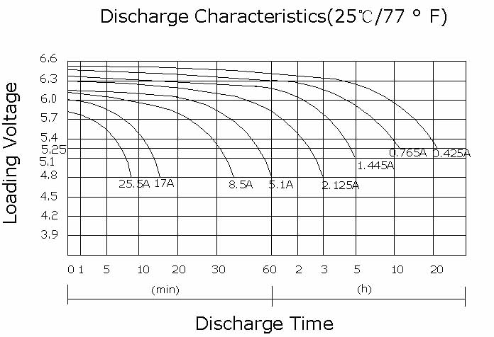
Capacity affected  by temperature |  |  | 40℃ （104 ⁰F）  25℃ （77 ⁰F）  0℃ （32 ⁰F） |  | 102%  100%  85%
Internal Resistance |  |  | Full charged battery (25℃,77 ⁰F) 15mΩ
Constant Voltage  Charge | Cycle |  | Initial Charging Current less than 2.55A  Voltage 7.20~7.50V at 25℃ (77 ⁰F )  Temperature Coefficient –15mV/℃
Constant Voltage  Charge | Standby |  | No limit on Initial Charging Current  Voltage 6.75~6.90V at 25℃ (77 ⁰F )  Temperature Coefficient –10mV/℃

