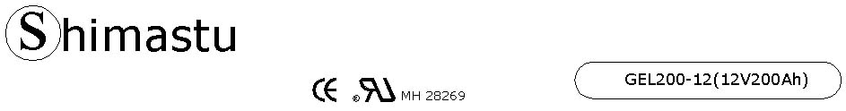
PHYSICAL SPECIFICATION
Nominal Voltage  Nominal Capacity (10HR) |  |  |  | 12V  200Ah |  | 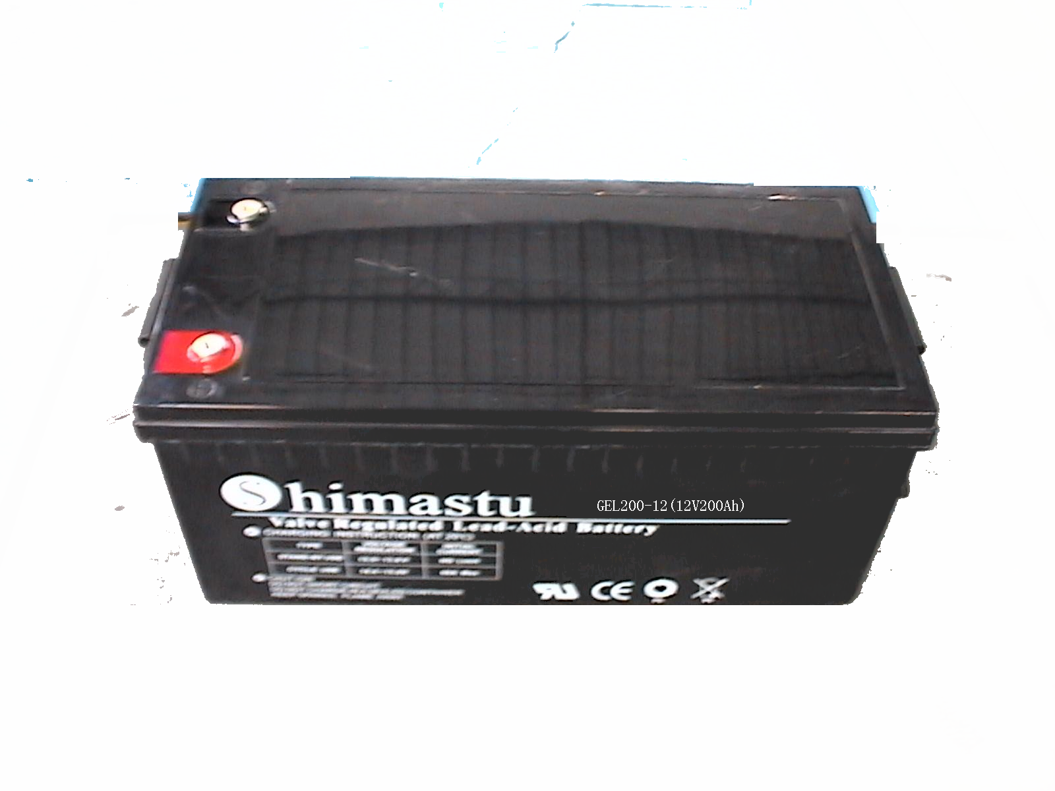
Dimension |  | Length  Width  Container Height  Total Height |  | 521±2mm （20.51 inches）  269±2mm (10.59 inches)  203±2mm (7.99 inches)  208±2mm (8.19 inches)
Weight |  |  |  | Approx. 67 Kg ( 147.6lbs)
Standard Terminal |  |  |  | Bolt-and-nut terminal  Bolt Type: M8
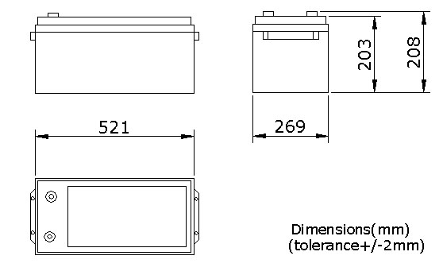 |  |  |  |  |  | 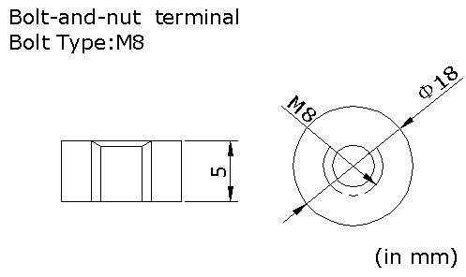

ELECTRICAL SPECIFICATION
Characteristics |  |  |  |  |  | Discharge curves @ 25℃ (77 °F)
Capacity |  |  | 20 hour rate (10A)  10 hour rate (20A)  5 hour rate (34A)  3 hour rate (50A)  1hour rate (120A) |  | 210Ah  200Ah  170Ah  150Ah  120Ah | 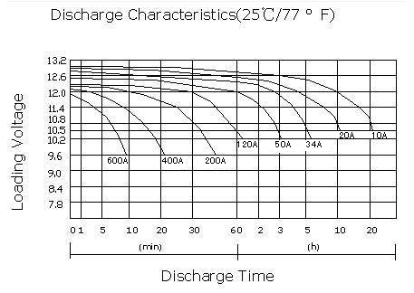
Capacity affected  by temperature |  |  | 40℃ （104 ⁰F）  25℃ （77 ⁰F）  0℃ （32 ⁰F） |  | 102%  100%  85%
Designed life |  |  | ≥750 Cycles @ 50% D.O.D(25℃)
Self Discharge |  |  | 3% of capacity declined per month at (25℃)
Internal Resistance |  |  | Full charged battery (25℃,77 ⁰F) 3mΩ
Constant Voltage  Charge | Cycle |  | Initial Charging Current less than 50A  Voltage 14.1~14.4V at 25℃ (77 ⁰F )  Temperature Coefficient –30mV/℃
Constant Voltage  Charge | Standby |  | No limit on Initial Charging Current  Voltage 13.5~13.8V at 25℃ (77 ⁰F )  Temperature Coefficient –20mV/℃

