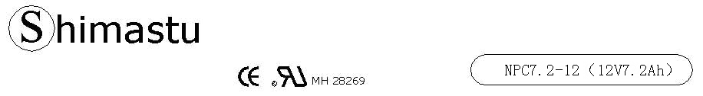

PHYSICAL SPECIFICATION
Nominal Voltage  Nominal Capacity (20HR) |  |  |  | 12V  7.2Ah |  | 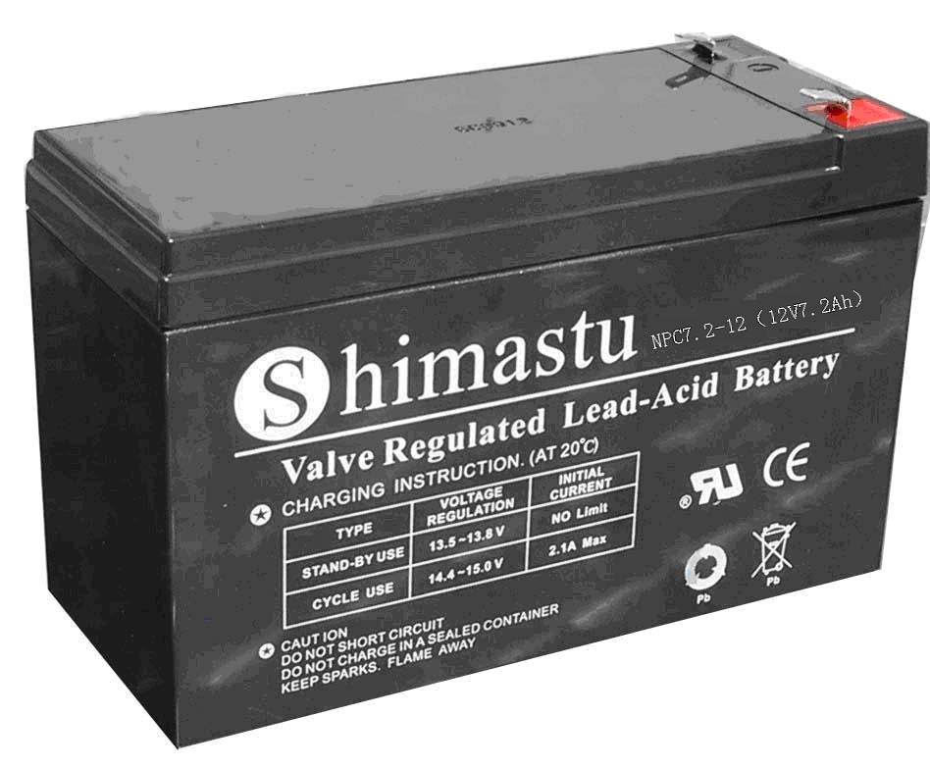
Dimension |  | Length  Width  Container Height  Total Height |  | 151±1mm （5.94 inches)  65±1mm (2.56 inches)  95±1mm (3.74 inches)  101±1mm (3.98 inches)
Weight |  |  |  | Approx. 2.35Kg (5.17lbs)
Standard Terminal |  |  |  | Fasten Tab No.187E
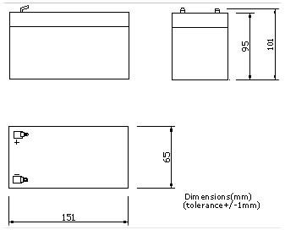 |  |  |  |  |  | 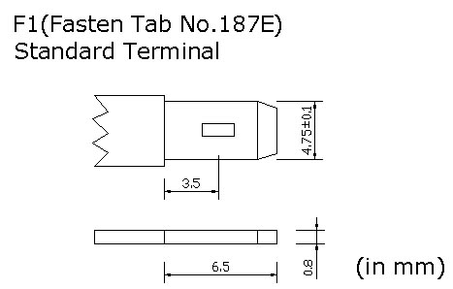

ELECTRICAL SPECIFICATION
Characteristics |  |  |  |  |  | Discharge curves @ 25℃ (77 °F)
Capacity |  |  | 20 hour rate (0.36A)  10 hour rate (0.65A)  5 hour rate (1.22A)  3 hour rate (1.8A)  1hour rate (4.32A) |  | 7.2Ah  6.5Ah  6.2Ah  5.4Ah  4.4Ah | 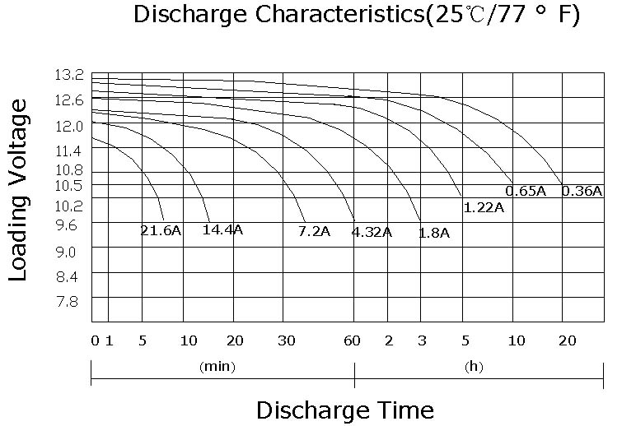
Capacity affected  by temperature |  |  | 40℃ （104 ⁰F）  25℃ （77 ⁰F）  0℃ （32 ⁰F） |  | 102%  100%  85%
Internal Resistance |  |  | Full charged battery (25℃,77 ⁰F) 18mΩ
Designed life |  |  | ≥600 Cycles @ 50% D.O.D
Self Discharge |  |  | 4% of capacity declined per month at (25℃)
Constant Voltage  Charge | Cycle |  | Initial Charging Current less than 2.2A  Voltage 14.4~15.0V at 25℃ (77 ⁰F )  Temperature Coefficient –5mV/℃
Constant Voltage  Charge | Standby |  | No limit on Initial Charging Current  Voltage 13.5~13.8V at 25℃ (77 ⁰F )  Temperature Coefficient –3.3mV/℃

