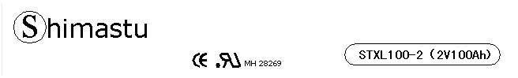

PHYSICAL SPECIFICATION
Nominal Voltage  Nominal Capacity (10HR) |  |  |  | 2V  100Ah |  | 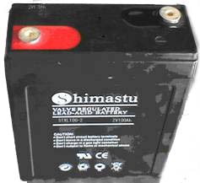
Dimension |  | Length  Width  Container Height  Total Height |  | 171±2mm （6.73 inches）  72±2mm (2.83 inches)  205±2mm (8.07 inches)  210±2mm (8.27 inches)
Weight |  |  |  | Approx. 5.9 Kg ( 13lbs)
Standard Terminal |  |  |  | Bolt-and-nuts terminal  Bolt Type: M8
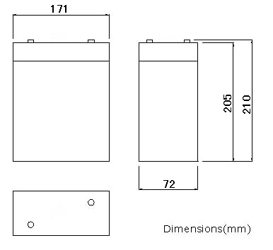 |  |  |  |  |  | 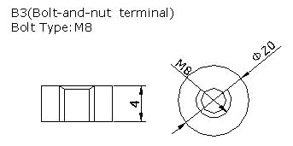

ELECTRICAL SPECIFICATION
Characteristics |  |  |  |  |  | Discharge curves @ 25℃ (77 °F)
Capacity |  |  | 100 hour rate (1A)  50 hour rate (2A)  10 hour rate (10A)  1hour rate (65A) |  | 110Ah  105Ah  100Ah  65Ah | 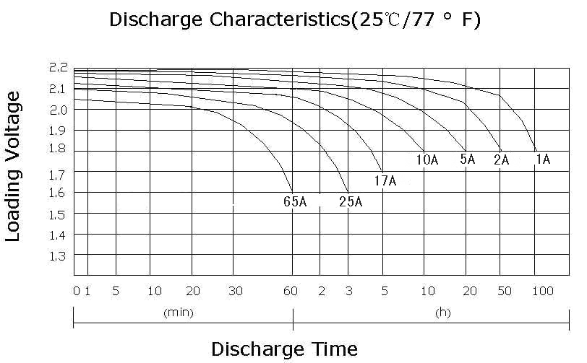
Capacity affected  by temperature |  |  | 40℃ （104 ⁰F）  25℃ （77 ⁰F）  0℃ （32 ⁰F） |  | 102%  100%  85%
Designed life |  |  | ≥3800 Cycles 20% DOD (25℃)
Internal Resistance |  |  | Full charged battery (25℃,77 ⁰F) 1.02mΩ
Constant Voltage  Charge | Cycle |  | Initial Charging Current less than 25A  Voltage 2.35~2.40V at 25℃ (77 ⁰F )  Temperature Coefficient –5mV/℃
Constant Voltage  Charge | Standby |  | No limit on Initial Charging Current  Voltage 2.25~2.30V at 25℃ (77 ⁰F )  Temperature Coefficient –3.3mV/℃

