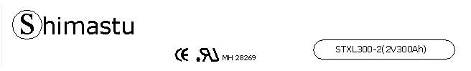

PHYSICAL SPECIFICATION
Nominal Voltage  Nominal Capacity (10HR) |  |  |  | 2V  300Ah |  | 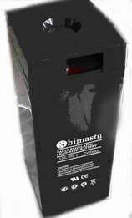
Dimension |  | Length  Width  Container Height  Total Height |  | 171±2mm （6.73 inches）  151±2mm (5.94 inches)  330±2mm (12.99 inches)  366±2mm (14.41 inches)
Weight |  |  |  | Approx. 21.5 Kg (47.34lbs)
Standard Terminal |  |  |  | Bolt-and-nuts terminal  Bolt Type: M8
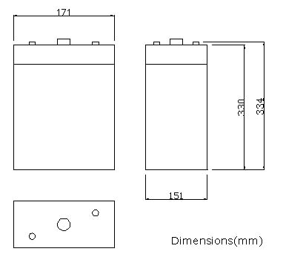 |  |  |  |  |  | 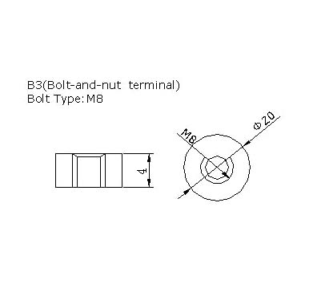

ELECTRICAL SPECIFICATION
Characteristics |  |  |  |  |  | Discharge curves @ 25℃ (77 °F)
Capacity |  |  | 100 hour rate (3A)  50 hour rate (6A)  10 hour rate (30A)  1hour rate (195A) |  | 330Ah  3150Ah  300Ah  195Ah | 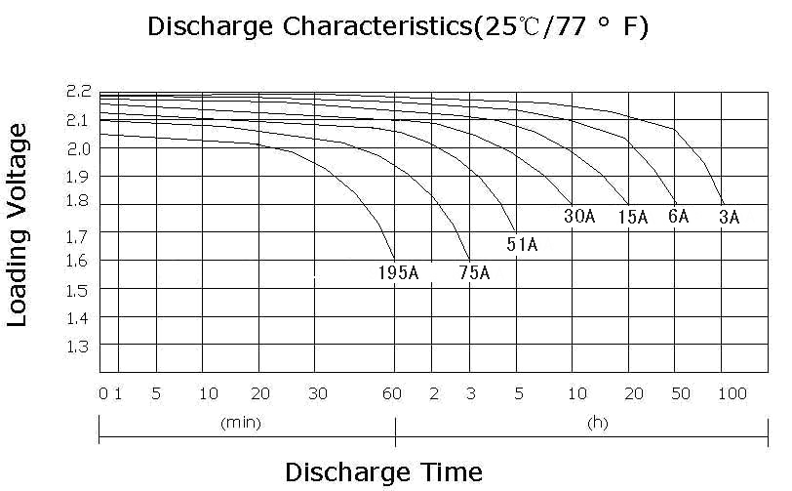
Capacity affected  by temperature |  |  | 40℃ （104 ⁰F）  25℃ （77 ⁰F）  0℃ （32 ⁰F） |  | 102%  100%  85%
Designed life |  |  | ≥4000 Cycles @ 20% DOD (25℃)
Internal Resistance |  |  | Full charged battery (25℃,77 ⁰F) 0.68mΩ
Constant Voltage  Charge | Cycle |  | Initial Charging Current less than 75A  Voltage 2.35~2.40V at 25℃ (77 ⁰F )  Temperature Coefficient –5mV/℃
Constant Voltage  Charge | Standby |  | No limit on Initial Charging Current  Voltage 2.25~2.30V at 25℃ (77 ⁰F )  Temperature Coefficient –3.3mV/℃

