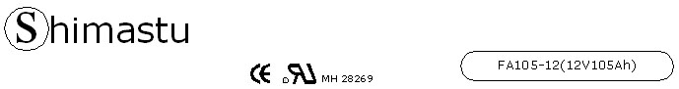

PHYSICAL SPECIFICATION
Nominal Voltage  Nominal Capacity (10HR) |  |  |  | 12V  105Ah
Dimension |  | Length  Width  Container Height  Total Height |  | 507±2mm （19.96inches）  110±2mm (4.33 inches)  223±2mm (8.78 inches)  238±2mm (9.37inches)
Weight |  |  |  | Approx. 36Kg ( 79.34lbs)
Standard Terminal |  |  |  | Bolt-and-nut terminal  Bolt Type: M6
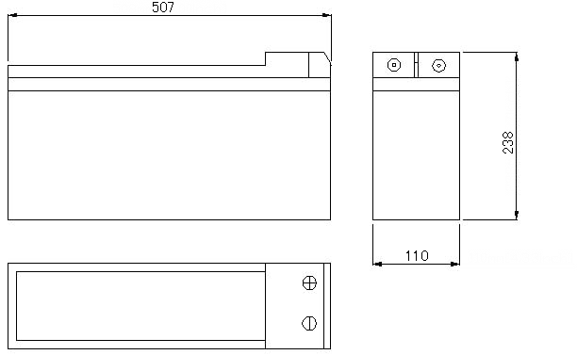 |  |  |  |  |  | 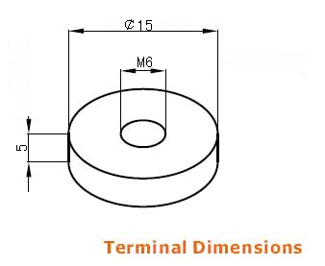

ELECTRICAL SPECIFICATION
Characteristics |  |  |  |  |  | Discharge curves @ 25℃ (77 °F)
Capacity |  |  | 20 hour rate (5.25A)  10 hour rate (10.5A)  5hour rate (17.85A)  3hour rate (26.25A)  1hour rate (63A) |  | 110Ah  105Ah  90Ah  79Ah  63Ah | 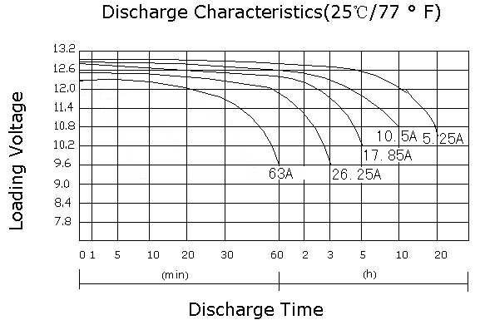
Capacity affected  by temperature |  |  | 40℃ （104 ⁰F）  25℃ （77 ⁰F）  0℃ （32 ⁰F） |  | 102%  100%  85%
Internal Resistance |  |  | Full charged battery (25℃,77 ⁰F) 4.5mΩ
Designed life |  |  | ≥10 years (25℃,77 ⁰F)
Constant Voltage  Charge | Cycle |  | Initial Charging Current less than 25A  Voltage 14.1~14.4V at 25℃ (77 ⁰F )  Temperature Coefficient –5mV/℃
Constant Voltage  Charge | Standby |  | No limit on Initial Charging Current  Voltage 13.5~13.8V at 25℃ (77 ⁰F )  Temperature Coefficient –3.3mV/℃

