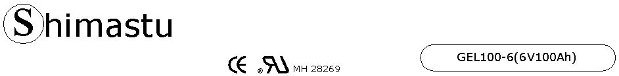

PHYSICAL SPECIFICATION
Nominal Voltage  Nominal Capacity (10HR) |  |  |  | 6V  100Ah |  | 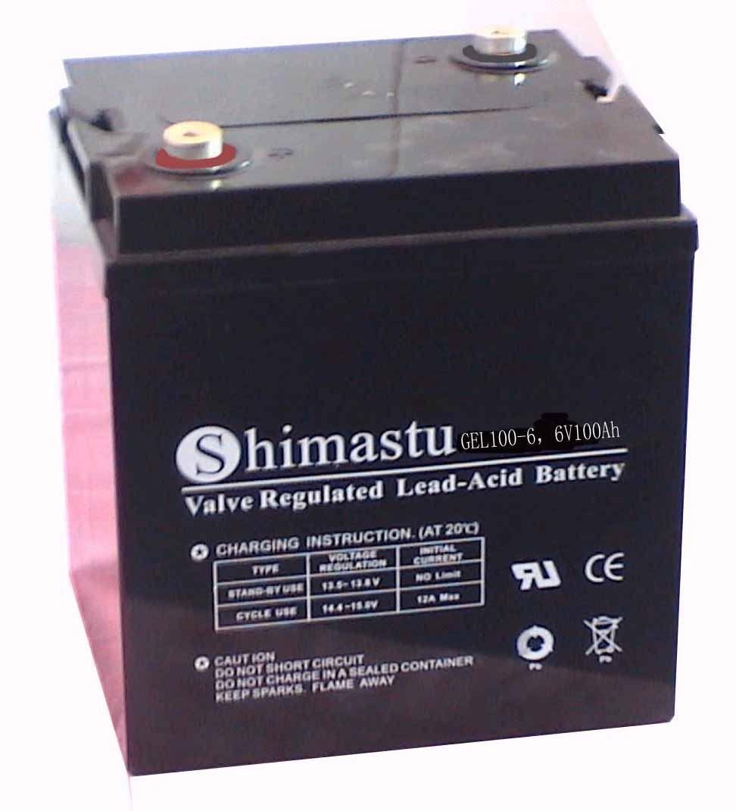
Dimension |  | Length  Width  Container Height  Total Height |  | 195±2mm （7.68 inches）  170±2mm (6.69 inches)  206±2mm (8.11 inches)  213±2mm (8.38 inches)
Weight |  |  |  | Approx. 15.5Kg ( 34.16lbs)
Standard Terminal |  |  |  | Bolt-and-nuts terminal  Bolt Type: M8
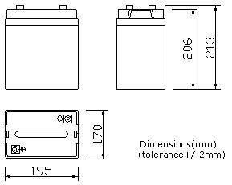 |  |  |  |  |  | 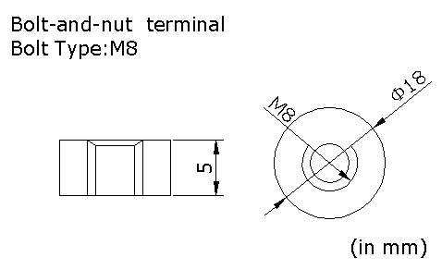

ELECTRICAL SPECIFICATION
Characteristics |  |  |  |  |  | Discharge curves @ 25℃ (77 °F)
Capacity |  |  | 20 hour rate (5A)  10 hour rate (10A)  5 hour rate (17A)  3 hour rate (25A)  1hour rate (60A) |  | 105Ah  100Ah  85Ah  75Ah  60Ah | 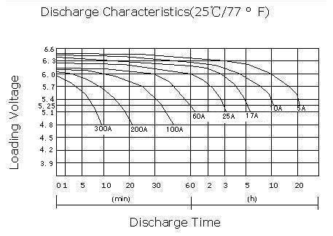
Capacity affected  by temperature |  |  | 40℃ （104 ⁰F）  25℃ （77 ⁰F）  0℃ （32 ⁰F） |  | 102%  100%  85%
Designed life |  |  | 10 years (floating) or >750 Cycles @ 50% D.O.D
Self Discharge |  |  | 3% of capacity declined per month at (25℃)
Internal Resistance |  |  | Full charged battery (25℃,77 ⁰F) 4mΩ
Constant Voltage  Charge | Cycle |  | Initial Charging Current less than 25A  Voltage 7.05~7.20V at 25℃ (77 ⁰F )  Temperature Coefficient –15mV/℃
Constant Voltage  Charge | Standby |  | No limit on Initial Charging Current  Voltage 6.75~6.90V at 25℃ (77 ⁰F )  Temperature Coefficient –10mV/℃

