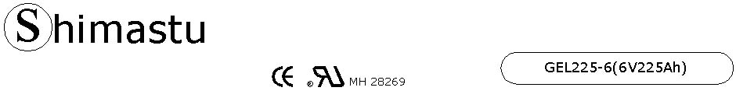

PHYSICAL SPECIFICATION
Nominal Voltage  Nominal Capacity (10HR) |  |  |  | 6V  225Ah |  | 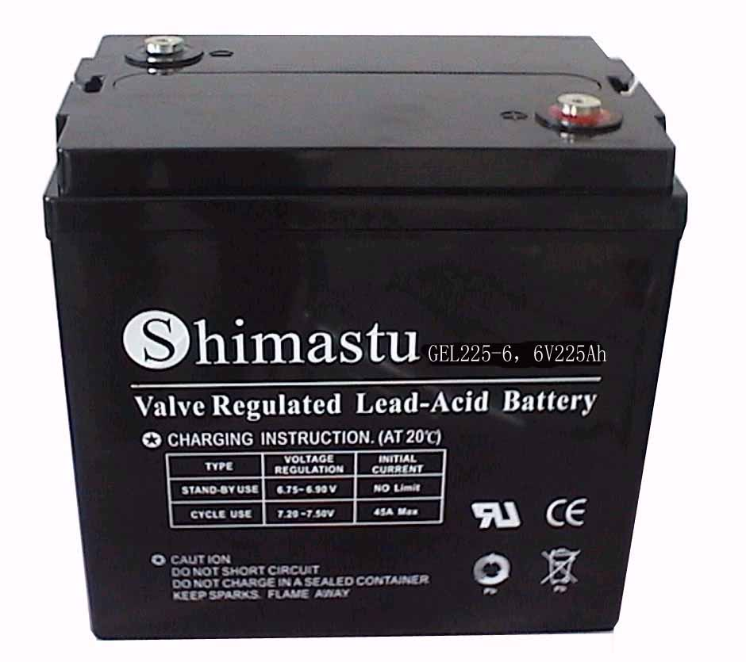
Dimension |  | Length  Width  Container Height  Total Height |  | 260±2mm （10.24 inches）  180±2mm (7.09 inches)  247±2mm (9.72 inches)  254±2mm (10.00 inches)
Weight |  |  |  | Approx. 30.5Kg (67.22lbs)
Standard Terminal |  |  |  | Bolt-and-nuts terminal  Bolt Type: M8
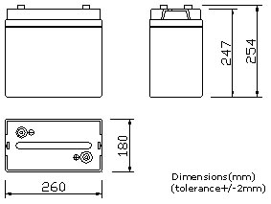 |  |  |  |  |  | 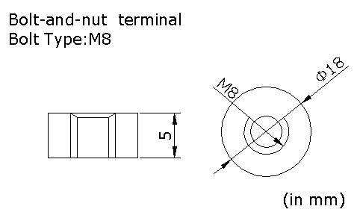

ELECTRICAL SPECIFICATION
Characteristics |  |  |  |  |  | Discharge curves @ 25℃ (77 °F)
Capacity |  |  | 20 hour rate (11.25A)  10 hour rate (22.5A)  5 hour rate (38.25A)  3 hour rate (56.25A)  1hour rate (135A) |  | 230Ah  225Ah  192Ah  169Ah  135Ah | 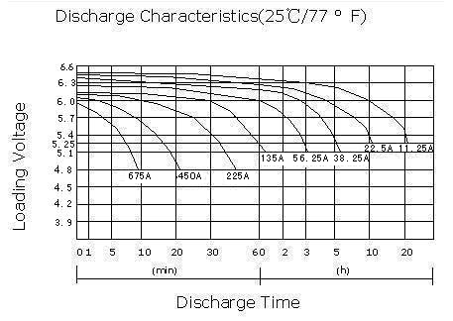
Capacity affected  by temperature |  |  | 40℃ （104 ⁰F）  25℃ （77 ⁰F）  0℃ （32 ⁰F） |  | 102%  100%  85%
Internal Resistance |  |  | Full charged battery (25℃,77 ⁰F) 3mΩ
Constant Voltage  Charge | Cycle |  | Initial Charging Current less than 56.25A  Voltage 7.05~7.20V at 25℃ (77 ⁰F )  Temperature Coefficient –15mV/℃
Constant Voltage  Charge | Standby |  | No limit on Initial Charging Current  Voltage 6.75~6.90V at 25℃ (77 ⁰F )  Temperature Coefficient –10mV/℃

