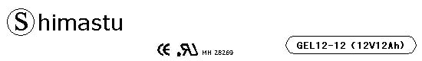

PHYSICAL SPECIFICATION
Nominal Voltage  Nominal Capacity (20HR) |  |  |  | 12V  12Ah |  | 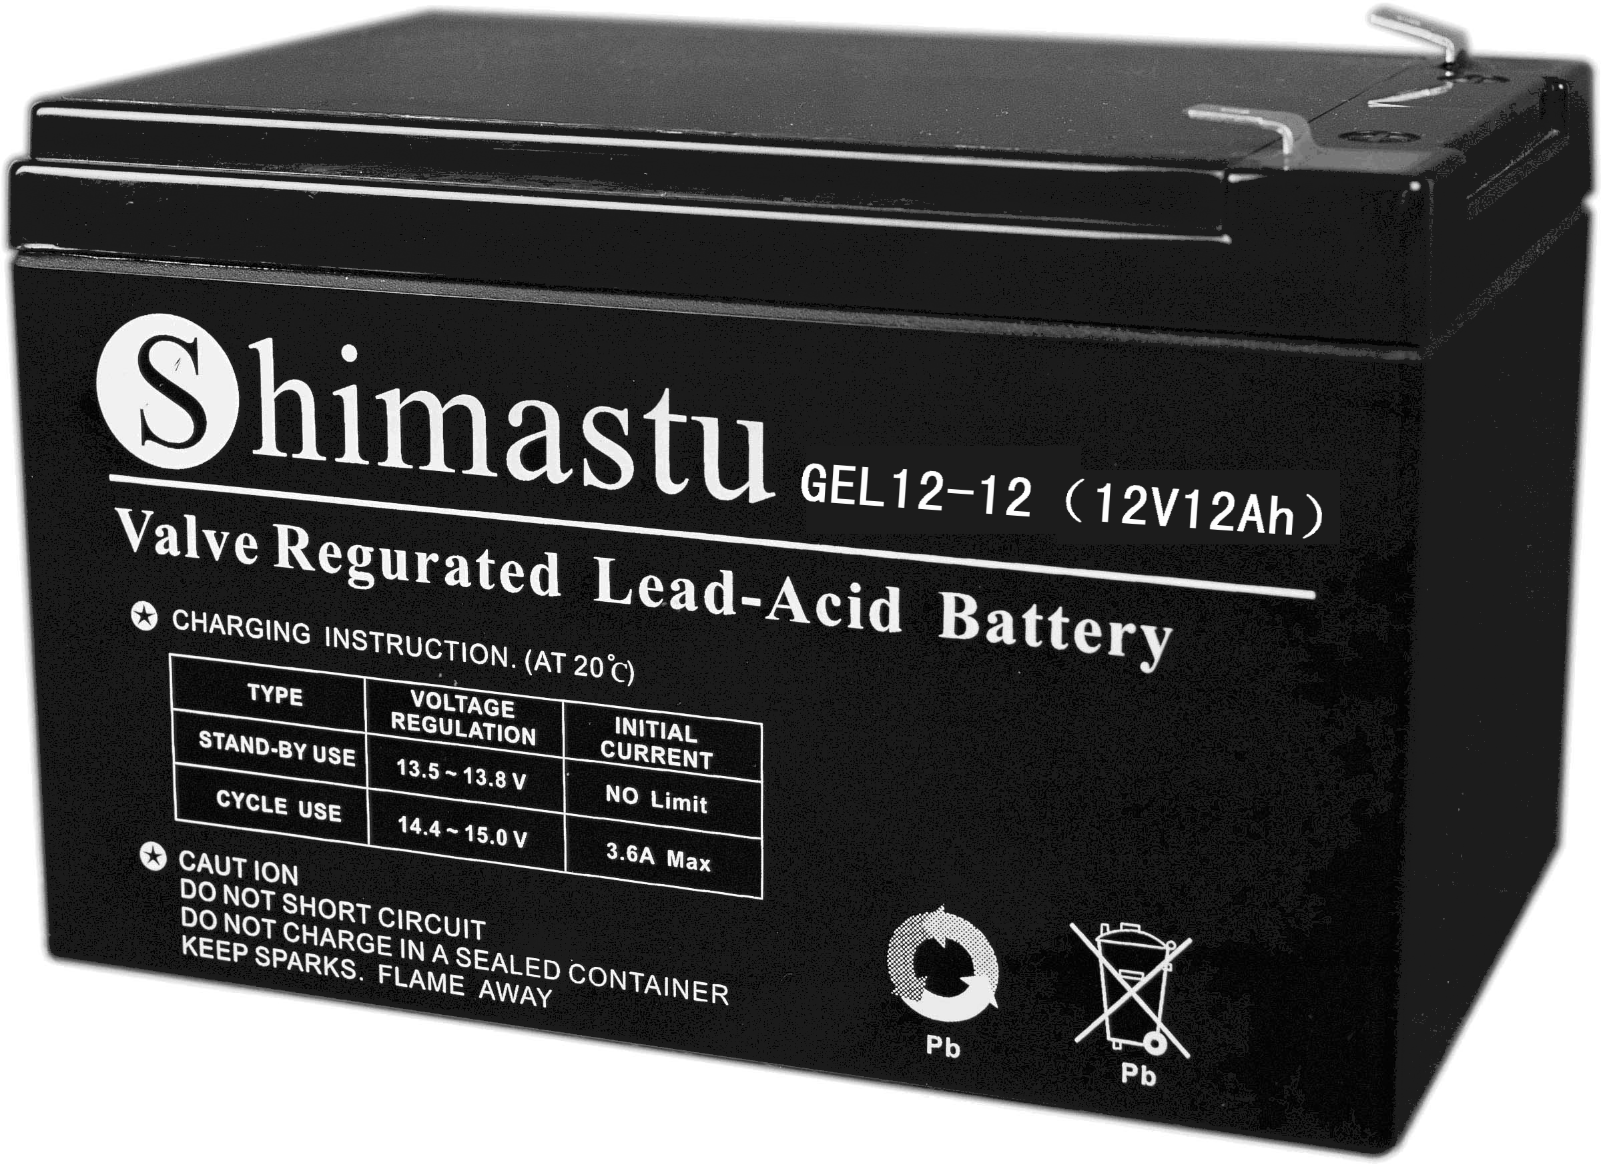
Dimension |  | Length  Width  Container Height  Total Height |  | 151±1mm （5.94 inches）  99±1mm (3.90 inches)  96±1mm (36.61inches)  101±1mm (3.98 inches)
Weight |  |  |  | Approx. 3.7Kg (8.15lbs)
Standard Terminal |  |  |  | Fasten Tab No.187E
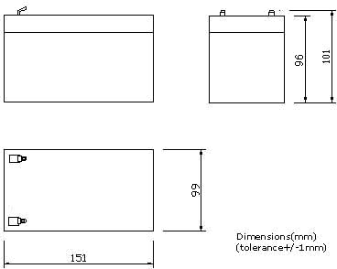 |  |  |  |  |  | 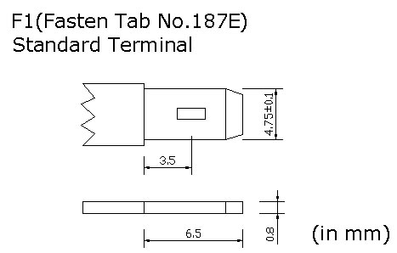

ELECTRICAL SPECIFICATION
Characteristics |  |  |  |  |  | Discharge curves @ 25℃ (77 °F)
Capacity |  |  | 20 hour rate (0.6A)  10 hour rate (1.08A)  5 hour rate (2.04A)  3hour rate (3A)  1hour rate (7.2A) |  | 12Ah  10.8Ah  10.2Ah  9Ah  7.2Ah | 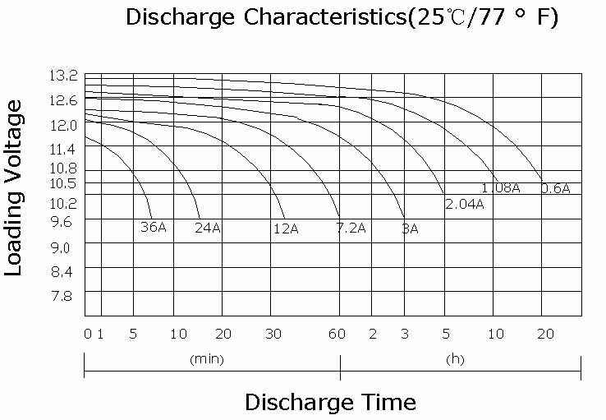
Capacity affected  by temperature |  |  | 40℃ （104 ⁰F）  25℃ （77 ⁰F）  0℃ （32 ⁰F） |  | 102%  100%  85%
Internal Resistance |  |  | Full charged battery (25℃,77 ⁰F) 19.3mΩ
Designed life |  |  | ≥720 Cycles @ 50% DOD (25℃)
Constant Voltage  Charge | Cycle |  | Initial Charging Current less than 3.6A  Voltage 14.4~15.0V at 25℃ (77 ⁰F )  Temperature Coefficient –5mV/℃
Constant Voltage  Charge | Standby |  | No limit on Initial Charging Current  Voltage 13.5~13.8V at 25℃ (77 ⁰F )  Temperature Coefficient –3.3mV/℃

