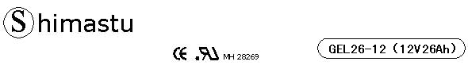

PHYSICAL SPECIFICATION
Nominal Voltage  Nominal Capacity (10HR) |  |  |  | 12V  26Ah |  | 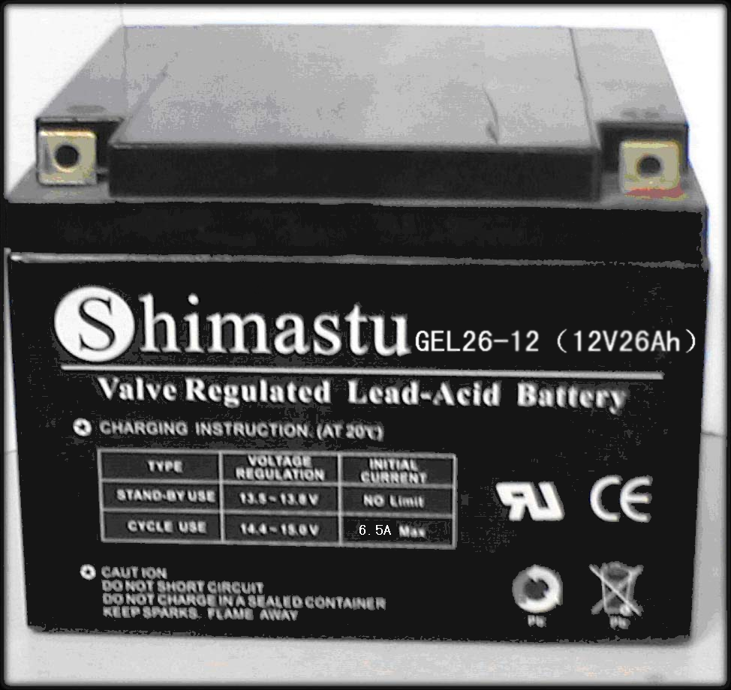
Dimension |  | Length  Width  Container Height  Total Height |  | 176±1mm （6.93 inches)  166±1mm (6.54 inches)  125±1mm (4.92 inches)  125±1mm (4.92 inches)
Weight |  |  |  | Approx. 9Kg (19.84lbs)
Standard Terminal |  |  |  | Bolt-and-nut terminal  Bolt Type: M5
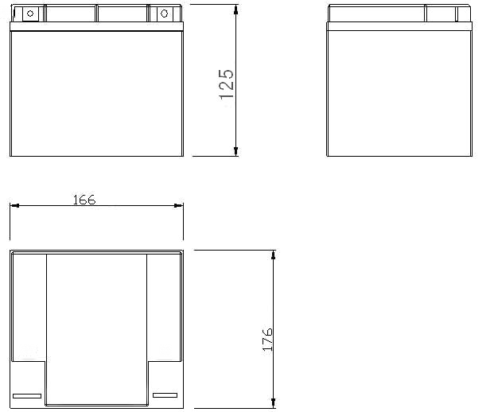 |  |  |  |  |  | 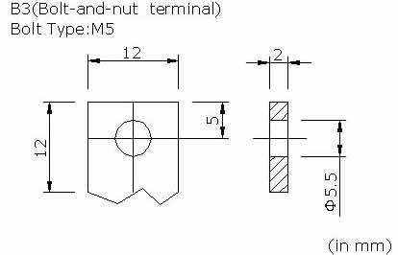

ELECTRICAL SPECIFICATION
Characteristics |  |  |  |  |  | Discharge curves @ 25℃ (77 °F)
Capacity |  |  | 10 hour rate (2.6A)  5 hour rate (4.42A)  3 hour rate (6.5A)  1hour rate (15.6A) |  | 26Ah  22Ah  19.5Ah  15.6Ah | 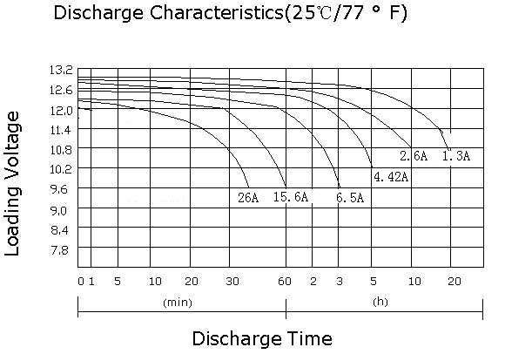
Capacity affected  by temperature |  |  | 40℃ （104 ⁰F）  25℃ （77 ⁰F）  0℃ （32 ⁰F） |  | 102%  100%  85%
Internal Resistance |  |  | Full charged battery (25℃,77 ⁰F) 12.3mΩ
Constant Voltage  Charge | Cycle |  | Initial Charging Current less than 6.5A  Voltage 14.1~14.4V at 25℃ (77 ⁰F )  Temperature Coefficient –5mV/℃
Constant Voltage  Charge | Standby |  | No limit on Initial Charging Current  Voltage 13.5~13.8V at 25℃ (77 ⁰F )  Temperature Coefficient –3.3mV/℃

