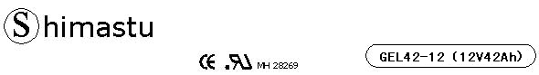
PHYSICAL SPECIFICATION
Nominal Voltage  Nominal Capacity (10HR) |  |  |  | 12V  42Ah |  | 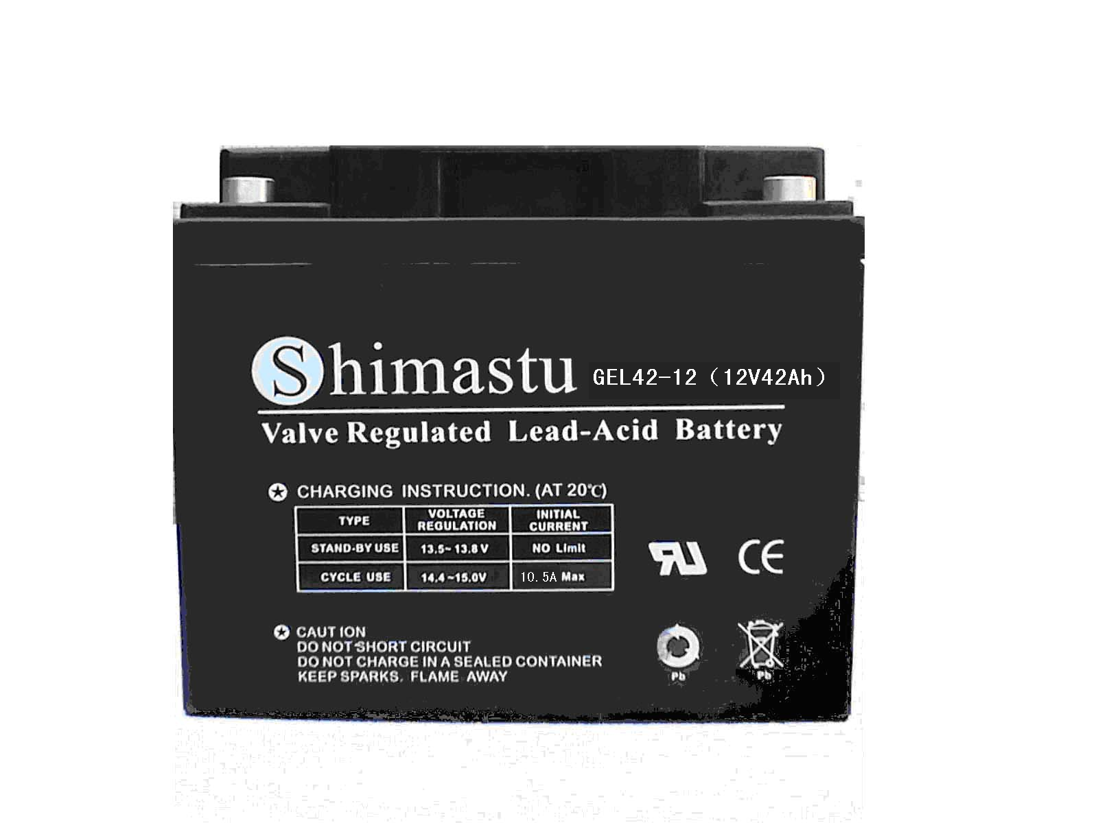
Dimension |  | Length  Width  Container Height  Total Height |  | 198±2mm （7.80 inches）  166±2mm (6.53 inches)  170±2mm (6.69 inches)  170±2mm (6.69 inches)
Weight |  |  |  | Approx. 14.8Kg ( 32.6lbs)
Standard Terminal |  |  |  | Bolt-and-nut lead terminal  Bolt Type: M6
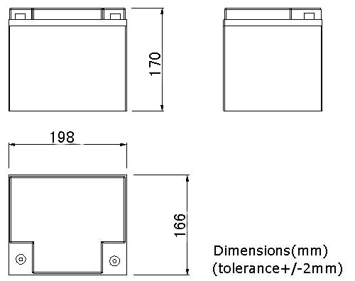 |  |  |  |  |  | 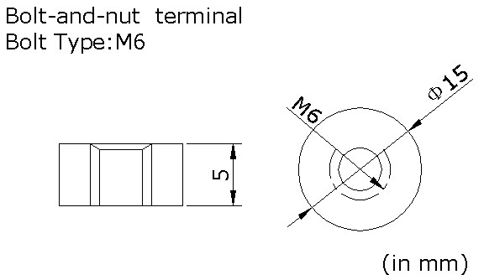

ELECTRICAL SPECIFICATION
Characteristics |  |  |  |  |  | Discharge curves @ 25℃ (77 °F)
Capacity |  |  | 10 hour rate (4.2A)  5 hour rate (7.14A)  3 hour rate (10.5A)  1hour rate (25.2A) |  | 42Ah  35.7Ah  31.5Ah  25.2Ah | 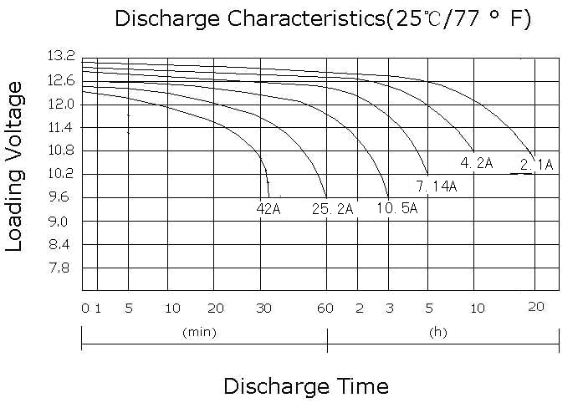
Capacity affected  by temperature |  |  | 40℃ （104 ⁰F）  25℃ （77 ⁰F）  0℃ （32 ⁰F） |  | 102%  100%  85%
Self Discharge |  |  | 3% of capacity declined per month at (25℃)
Internal Resistance |  |  | Full charged battery (25℃,77 ⁰F) 9.8mΩ
Constant Voltage  Charge | Cycle |  | Initial Charging Current less than 10.5A  Voltage 14.1~14.4V at 25℃ (77 ⁰F )  Temperature Coefficient –5mV/℃
Constant Voltage  Charge | Standby |  | No limit on Initial Charging Current  Voltage 13.5~13.8V at 25℃ (77 ⁰F )  Temperature Coefficient –3.3mV/℃

