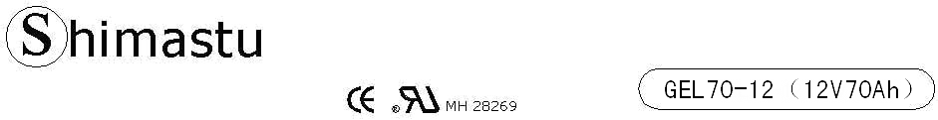

PHYSICAL SPECIFICATION
Nominal Voltage  Nominal Capacity (10HR) |  |  |  | 12V  70Ah |  | 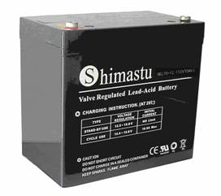
Dimension |  | Length  Width  Container Height  Total Height |  | 259±2mm （10.20 inches）  168±2mm (6.61 inches)  208±2mm (8.19 inches)  212±2mm (8.35 inches)
Weight |  |  |  | Approx.23.9Kg (52.63lbs)
Standard Terminal |  |  |  | Bolt-and-nut terminal  Bolt Type: M6
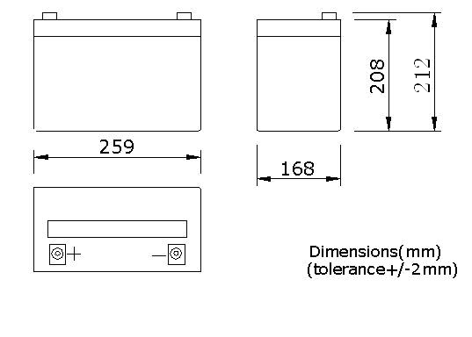 |  |  |  |  |  | 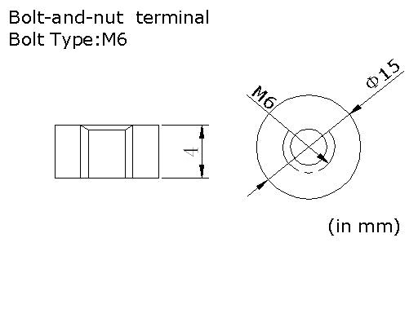

ELECTRICAL SPECIFICATION
Characteristics |  |  |  |  |  | Discharge curves @ 25℃ (77 °F)
Capacity |  |  | 10 hour rate (7.0A)  5hour rate (11.9A)  3hour rate (17.5A)  1hour rate (42A) |  | 70Ah  60Ah  52.5Ah  42Ah | 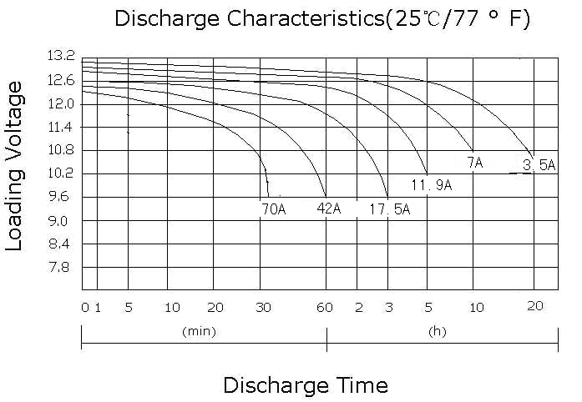
Capacity affected  by temperature |  |  | 40℃ （104 ⁰F）  25℃ （77 ⁰F）  0℃ （32 ⁰F） |  | 102%  100%  85%
Designed life |  |  | ≥720 Cycles 50% DOD (25℃)
Internal Resistance |  |  | Full charged battery (25℃,77 ⁰F)5.7mΩ
Constant Voltage  Charge | Cycle |  | Initial Charging Current less than 17.5A  Voltage 14.1~14.4V at 25℃ (77 ⁰F )  Temperature Coefficient –5mV/℃
Constant Voltage  Charge | Standby |  | No limit on Initial Charging Current  Voltage 13.5~13.8V at 25℃ (77 ⁰F )  Temperature Coefficient –3.3mV/℃
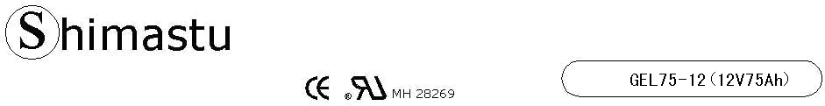
Cycle Service Life  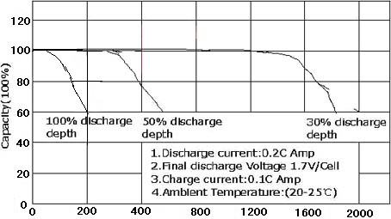 |  |  |  |  | Trickle (or Float) Service Life  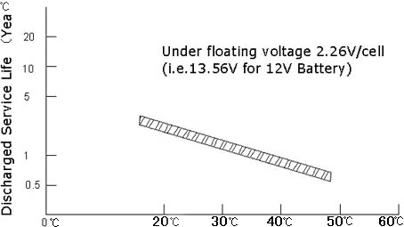
Storage Time (months)  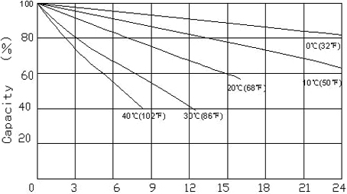 |  |  |  |  | Effect of temperature on capacity  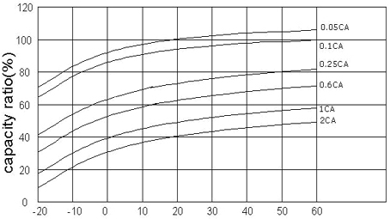
Charging Time (Hours)  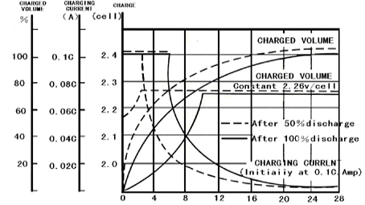 |  |  |  |  | Charging Procedures(12V series)
 |  |  |  |  | Application | Charging Voltage(V/Cell) |  |  |  |  |  |  | Max Charge Current
 |  |  |  |  | Application | Temperature |  | Set point |  |  | Allowable range
 |  |  |  |  | Cycle Use | 0.25℃  (77℉) |  | 14.2 |  |  | 14.1~~14.3 |  | 0.25C
 |  |  |  |  | Standby | 0.25℃  (77℉) |  | 2.275 |  |  | 2.25~~2.3 |  | 0.25C
Charging procedures (6V series) |  |  |  |  | Discharge Current VS. Discharge Voltage
Application | Charging Voltage(V) |  |  | Max Charge Current | Final Discharge Voltage  (V/Cell) |  | 1.75 |  | 1.7 |  |  | 1.55 |  | 1.3
Application | Temperature | Set point | Allowable range
Cycle Use | 0.25℃(77℉) | 7.1 | 7.05~~7.15 | 0.25C
 |  |  |  |  | Discharge Voltage  (V/Cell) |  | 0.2C＞（A） |  | 0。2C＜（A）＜  0。5C |  |  | 0。5C＜（A）＜1。0C |  | （A）＞  1。0C
Standby | 0.25℃(77℉) | 6.85 | 6.8~~6.9 | 0.25C
Charge the batteries at least once every twelve months ,if they are stored at 25℃ |  |  |  |  | Charging Method：
 |  |  |  |  | Constant Voltage |  |  |  |  | 14.1~~14.3V,5~~11h,Max.Current 0.1CA
 |  |  |  |  | Constant Current |  |  |  |  | 0.05CA*2h
Zhongshan Shimastu Electronic Technology Co., Ltd
ADD: Nan Sui Industrial Zone , Nantou Town , Zhongshan ,Guang Dong , China
Website: www.shimastu.com
Tel:+86-760-3133619 Fax:+86-760-3133629

