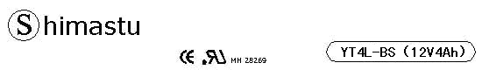

PHYSICAL SPECIFICATION
Nominal Voltage  Nominal Capacity (10HR) |  |  |  | 12V  4Ah |  |  | 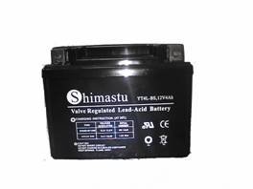
Dimension |  | Length  Width  Container Height  Total Height |  | 114±1mm （4.41 inches）  69±1mm (2.72 inches)  89±1mm (3.5 inches)  89±1mm (3.5 inches)
Weight |  |  |  | Approx. 1.58Kg (3.48lbs)
Standard Terminal |  |  |  | F1-Fasten Tab M01
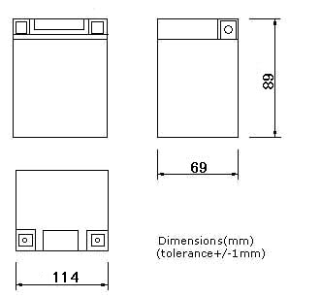 |  |  |  |  |  |  | 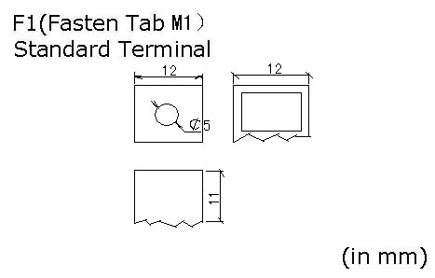

ELECTRICAL SPECIFICATION
Characteristics |  |  |  |  |  |  | Discharge curves @ 25℃ (77 °F)
Capacity |  |  | 10 hour rate (0.4A)  5 hour rate (0.68A)  3 hour rate (1.0A)  1hour rate (2.4A) |  |  | 4Ah  3.4Ah  3Ah  2.4Ah | 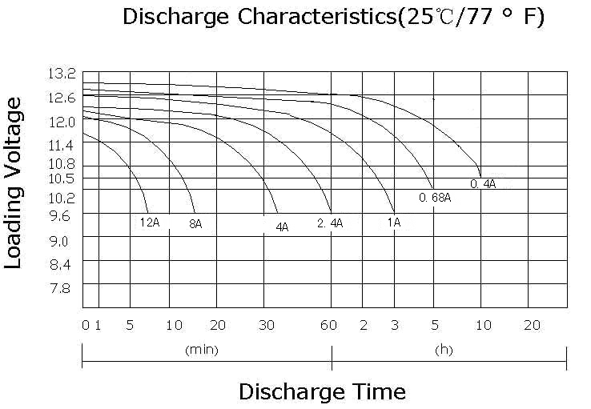
Capacity affected  by temperature |  |  | 40℃ （104 ⁰F）  25℃ （77 ⁰F）  0℃ （32 ⁰F） |  |  | 102%  100%  85%
Internal Resistance |  |  | Full charged battery (25℃,77 ⁰F) 15mΩ
Discharge at 32A for 5 seconds (-10℃) |  |  |  |  | ≥9.3V
Discharge at 32A for 90seconds (-10℃) |  |  |  |  | ≥6V
Constant Voltage  Charge | Cycle |  | Initial Charging Current less than 1.2A  Voltage 14.4~15.0V at 25℃ (77 ⁰F )  Temperature Coefficient –5mV/℃
Constant Voltage  Charge | Standby |  | No limit on Initial Charging Current  Voltage 13.5~13.8V at 25℃ (77 ⁰F )  Temperature Coefficient –3.3mV/℃

